**PORTAL ENHANCEMENTS / Revamp/ New Development**

**Production domain Propertycare.co.in, test domain propmgt.co.in**

**(now in shared hosting, silicon house)**

**Phase 1, Requirements – Draft  
  
1. Assumptions**

* 1. Over a period of 1-2 years, approximately 300 property consultants across India as FRANCHISE will login and use and run their daily work in this portal like publish buy, sell, rent ads and manage day-to-day work, robust design required to meet this requirement, initial approach should be THINK BIG, START SMALL, small scope discussed below. Choose the right technology to meeting this requirement. Initial phase 1 scope is only to list properties, generate lead, and tracking only by all devices like touchscreen TV, web, mobile app, tab etc. Residential and commercial properties will market in this portal.
  2. Agile methodology is the preferred approach. Backend table designs already available in MySQL (70 tables), can be leveraged wherever required. One onsite resource development preferred for quick interactive delivery, resource can be on rotation basis too, balance resource if required can be at offshore, please share proposal of onsite and offshore cost. Feel free to develop at our office at Singasandra, Hosur road, sufficient space available.
  3. Expected time of delivery, portal delivery 2 months. Expert skills required in technology, no learning time assumed, if any learning effort, should not be charged to us. Requirement phase 80% documentations actual business users UI/UX, infographics (15 diagrams, to be inserted in portal), icons approx 70, and simulated UI/UX using Adobe XD for better understanding of UI navigation, are captured and ready. Design architecture documentation (max 5-10 pages of diagrams) is fine to do knowledge transfer in case developer not available or leaving company etc. Robust, highly scalable end-to-end implementation architecture diagram required with suggested technology. MEAN, MDB Pro Kit of UI/UX is preferred technology.
  4. We have 3 business user testers in our office, as part of agile methodology, once unit tested and integration tested codes can be shared to our team in phased manner, can be tested immediately and raise bugs online tool to fix for developers, no need to wait for entire deliverables and raise bugs. During our testing your developer can work in next set of deliverables.
  5. Payment terms are milestone basis, split entire scope into milestones, payment will be made after 15 days of each milestone’s successful go live.
  6. If delivery not made on time, penalty clause needs to be discussed in proposal, because time is money.
  7. Non-disclosure agreement required to any other clients without our written consent, highly confidential, any breach in this, no further scope work will be given, contract will be terminated immediately, and all payment dues will not be paid.
  8. Light weight with minimum customization, in future easily manageable architecture required for portal, web-based product, mobile app etc.
  9. User login should be tagged to respective franchise
  10. Downtime should be 0.00001%
  11. Design should be highly scalable, provide excellent performance results, responsive, and portable to mobile app, tab etc with single code API approach.
  12. SaaS product means ‘web & mobile app based product’ for property management, 20-30% already done and using now for day-to-day business run in PHP. Since scalability and mobile portability problems, building new in MEAN.
  13. Extensive Google API map and Whatsapp API implementation skills required, since properties mapping to google location required at many places.
  14. All features discussed below should be mobile, tab enabled, separate mobile app required or not need to be assessed. Refer commonfloor.com, proptiger.com for more details.  
        
      Existing backend developed in PHP using now, for understanding purpose pasting few screenshots.

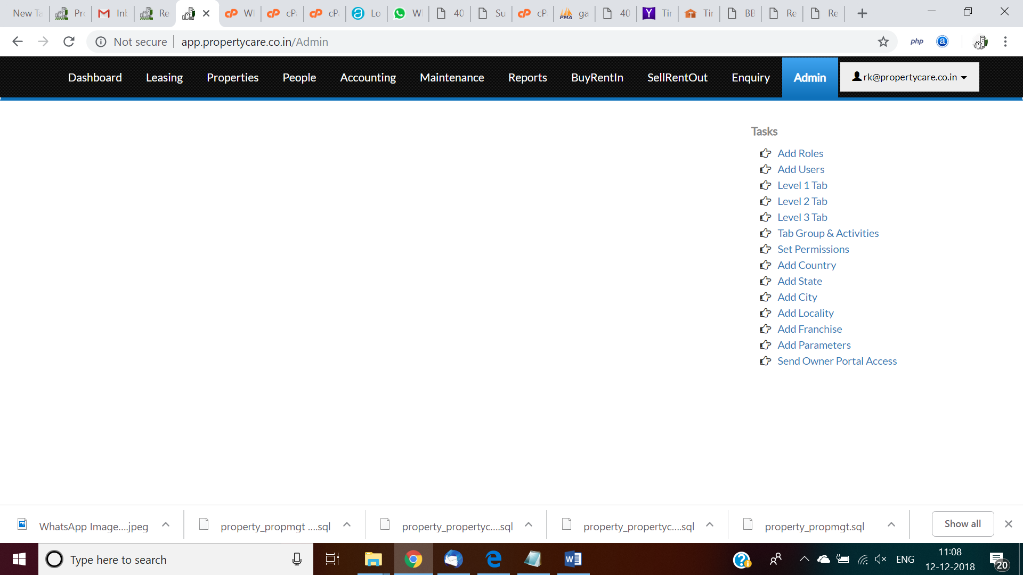  
  
Existing CMS:  
  
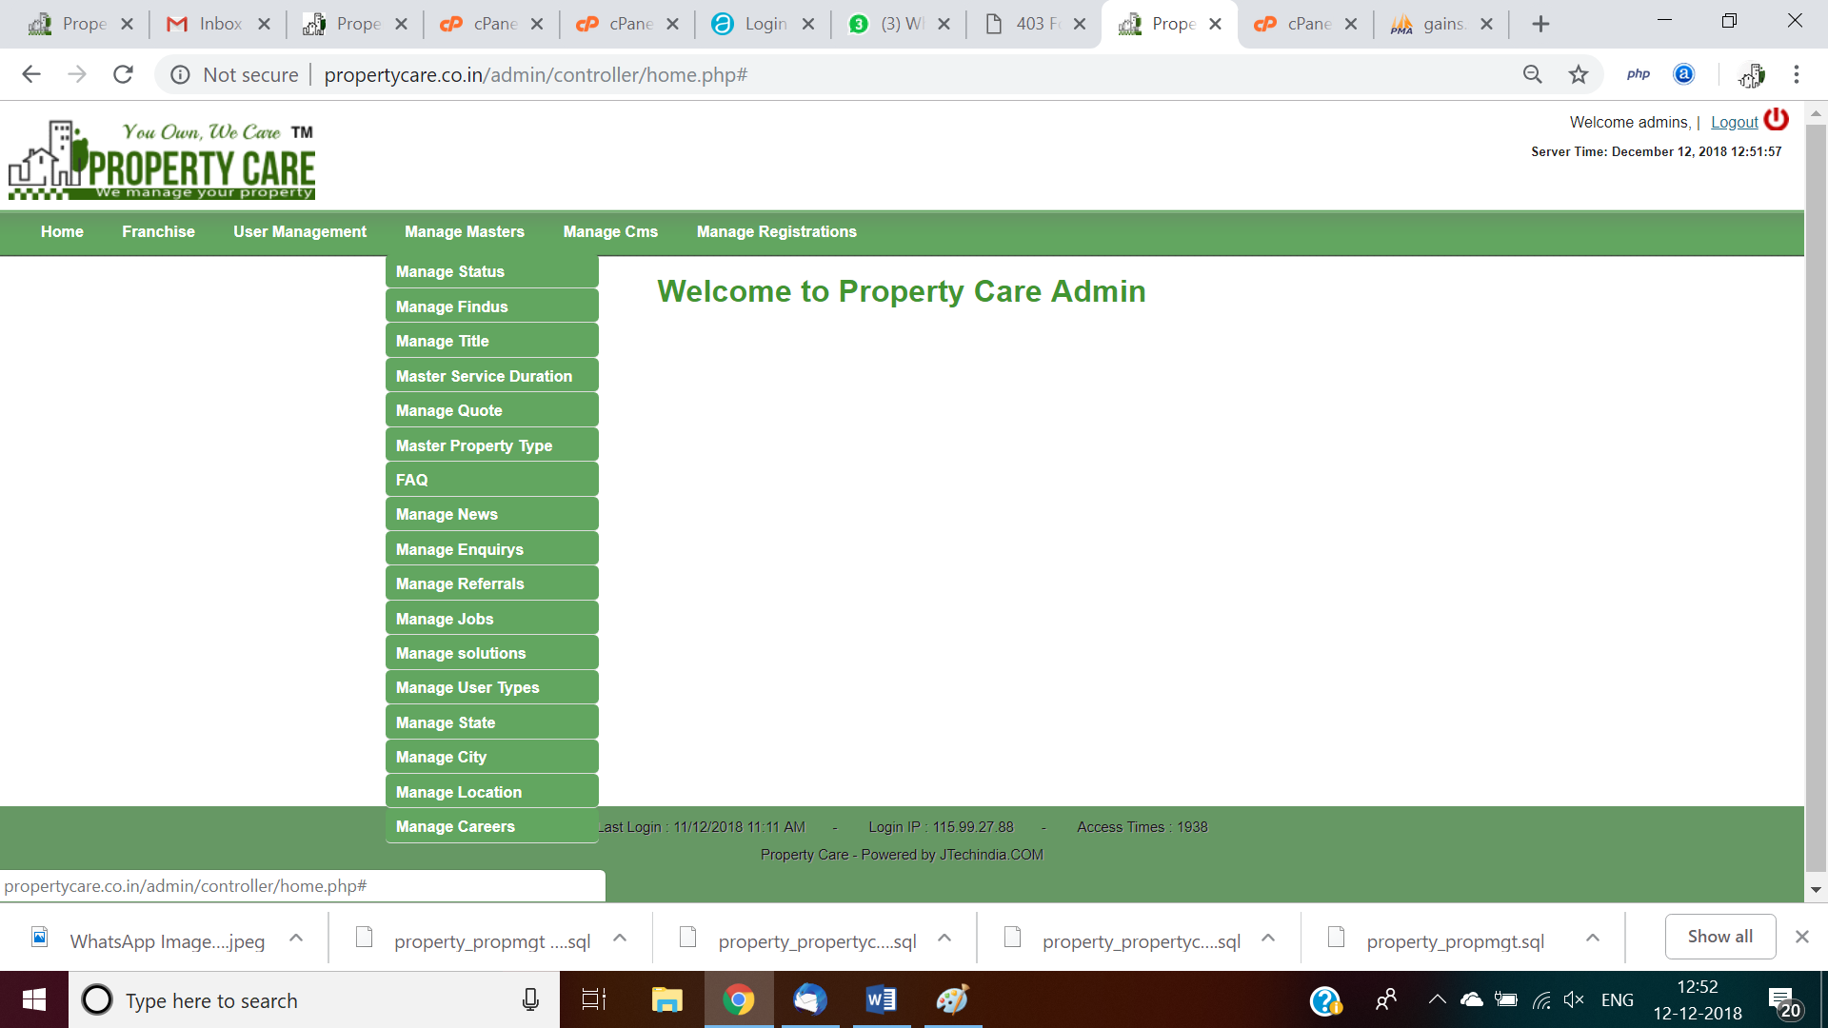  
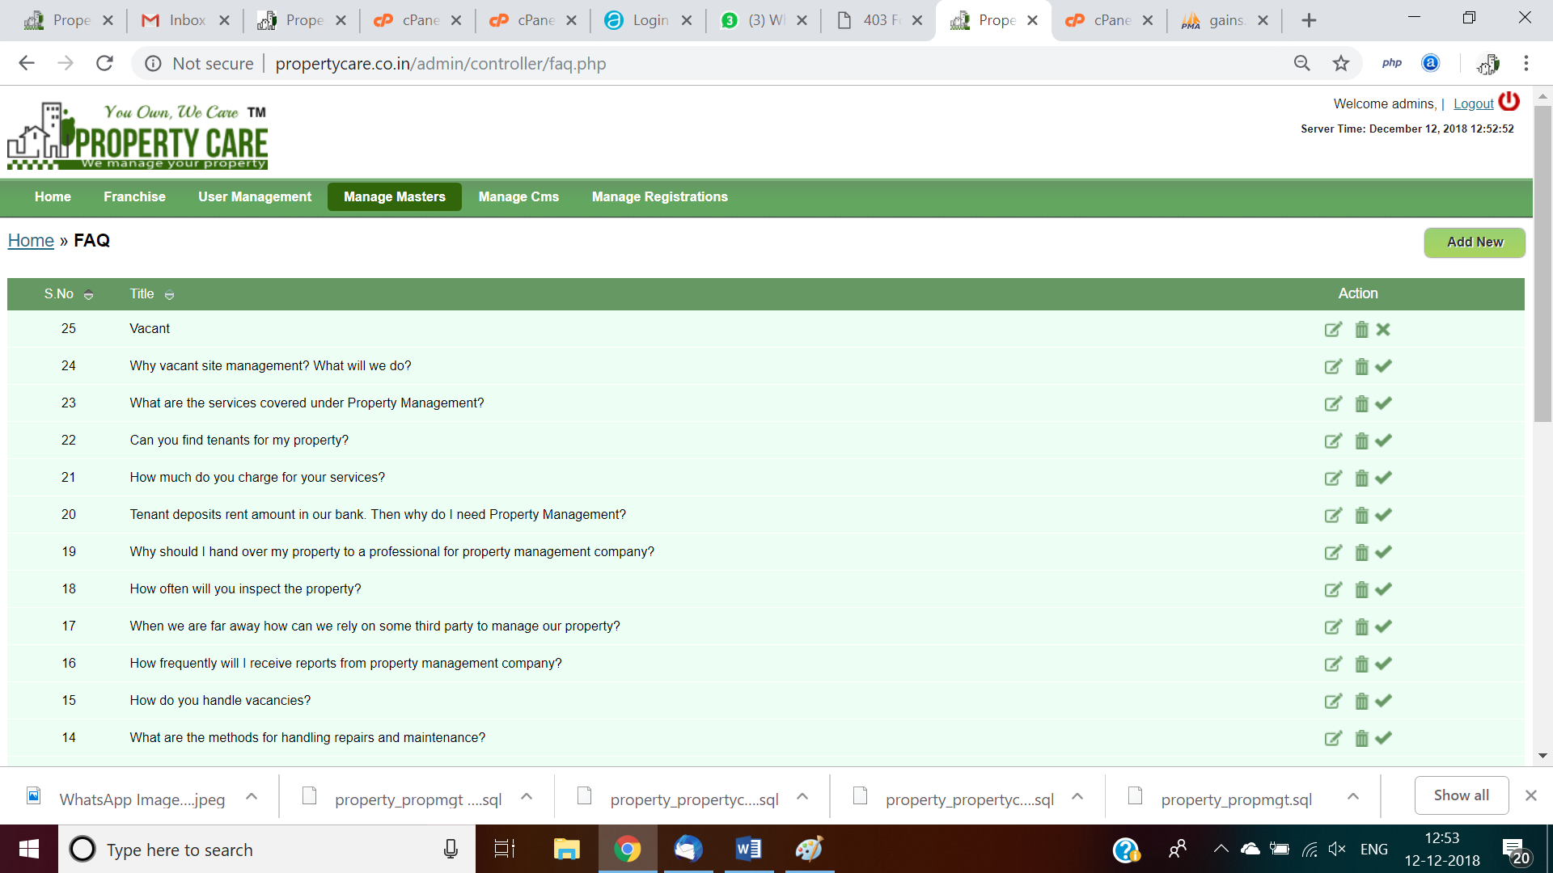  
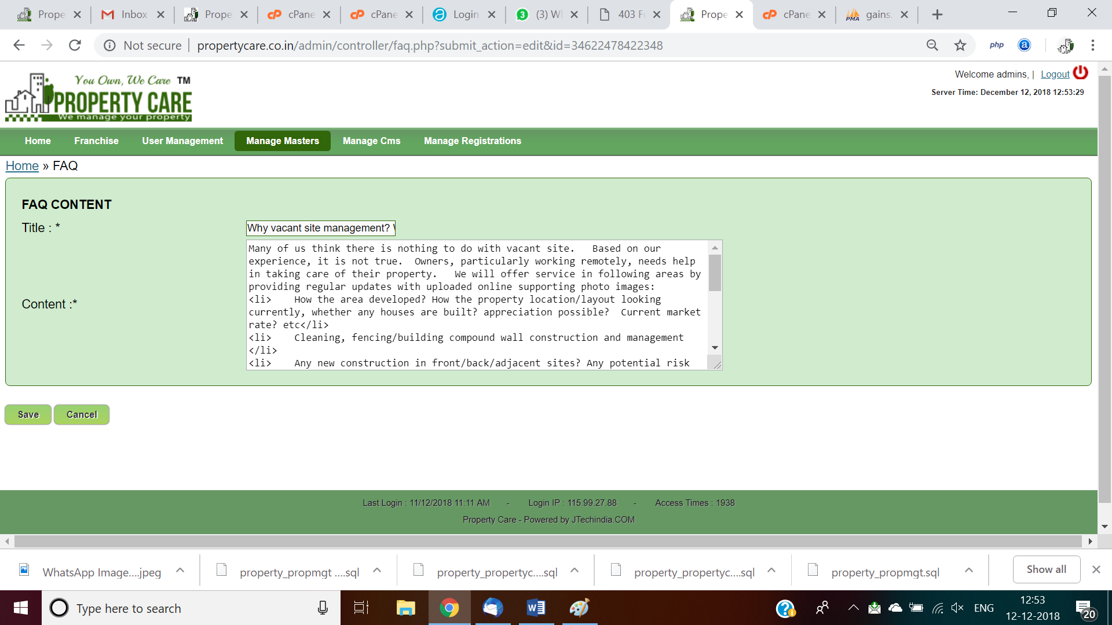

* 1. There are 2 MS Sql schema available now for
     1. Portal, tables available for   
        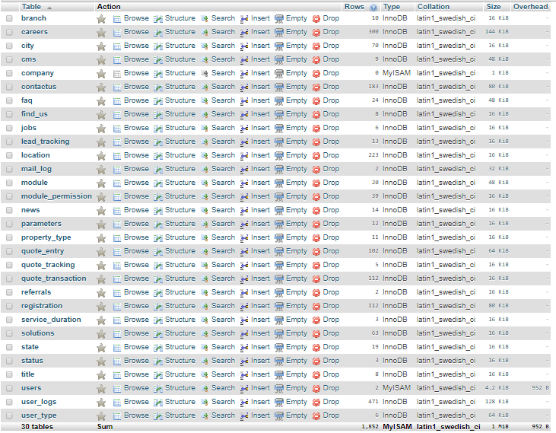
     2. SaaS product tables, leverage wherever possible  
        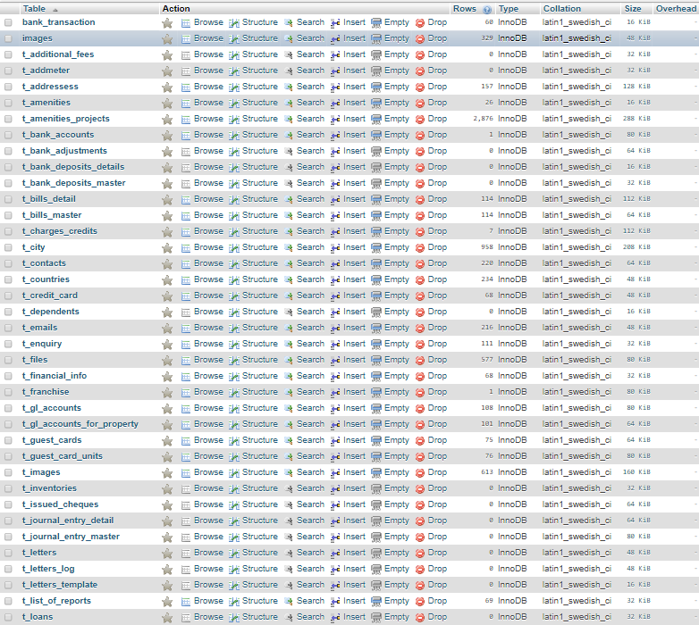

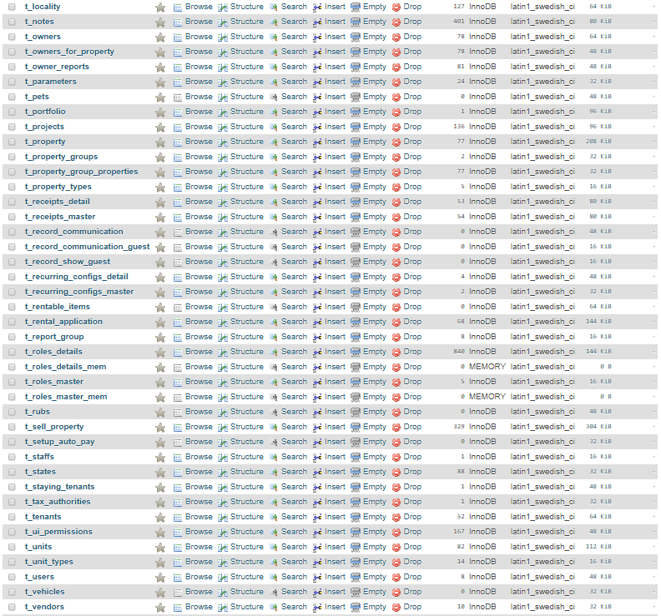  


1. **Home page tab**
   1. Nice design for property management site, competitor proptension.com, sangau.com, ad listing cos commonfloor.com, magicbricks.com, housing.com, nestaway.com
   2. Logo minor tweak required, Logo design with Reserved symbol, Registered Trade Mark
   3. Login
      1. Regular user login to publish owner sell/rent ads [While user create in backend need to select type as Regular user [/Agent/Builder/Property Manager/Corporate /Vendor/Subscribed Owner/Subscribed Tenant, future classifications]; Captcha/any other similar approach like 2 + 7 = ?9 required to avoid robot login, good decent security required, leverage face
      2. Initially collect full name, First name last name separately, mobile no, email id, leverage facebook login wherever possible, all mobile no should be with country code as NRI also will use, and verify email id by sending mail OTP to email id. Basic validation like no non-numeric in mobile no required. Future SMS may need to verify. Sample view:   
         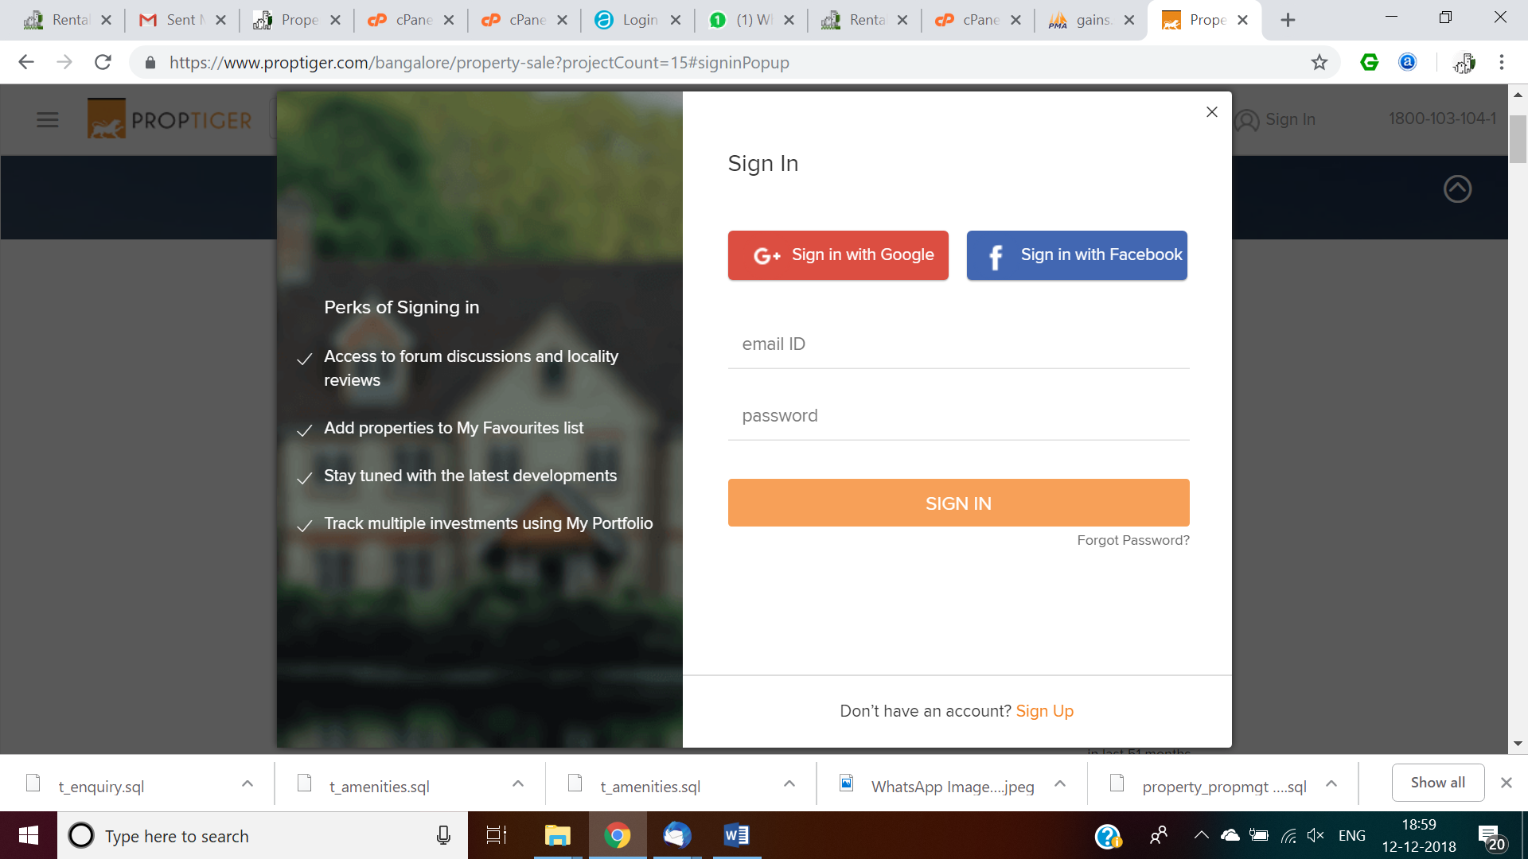  
         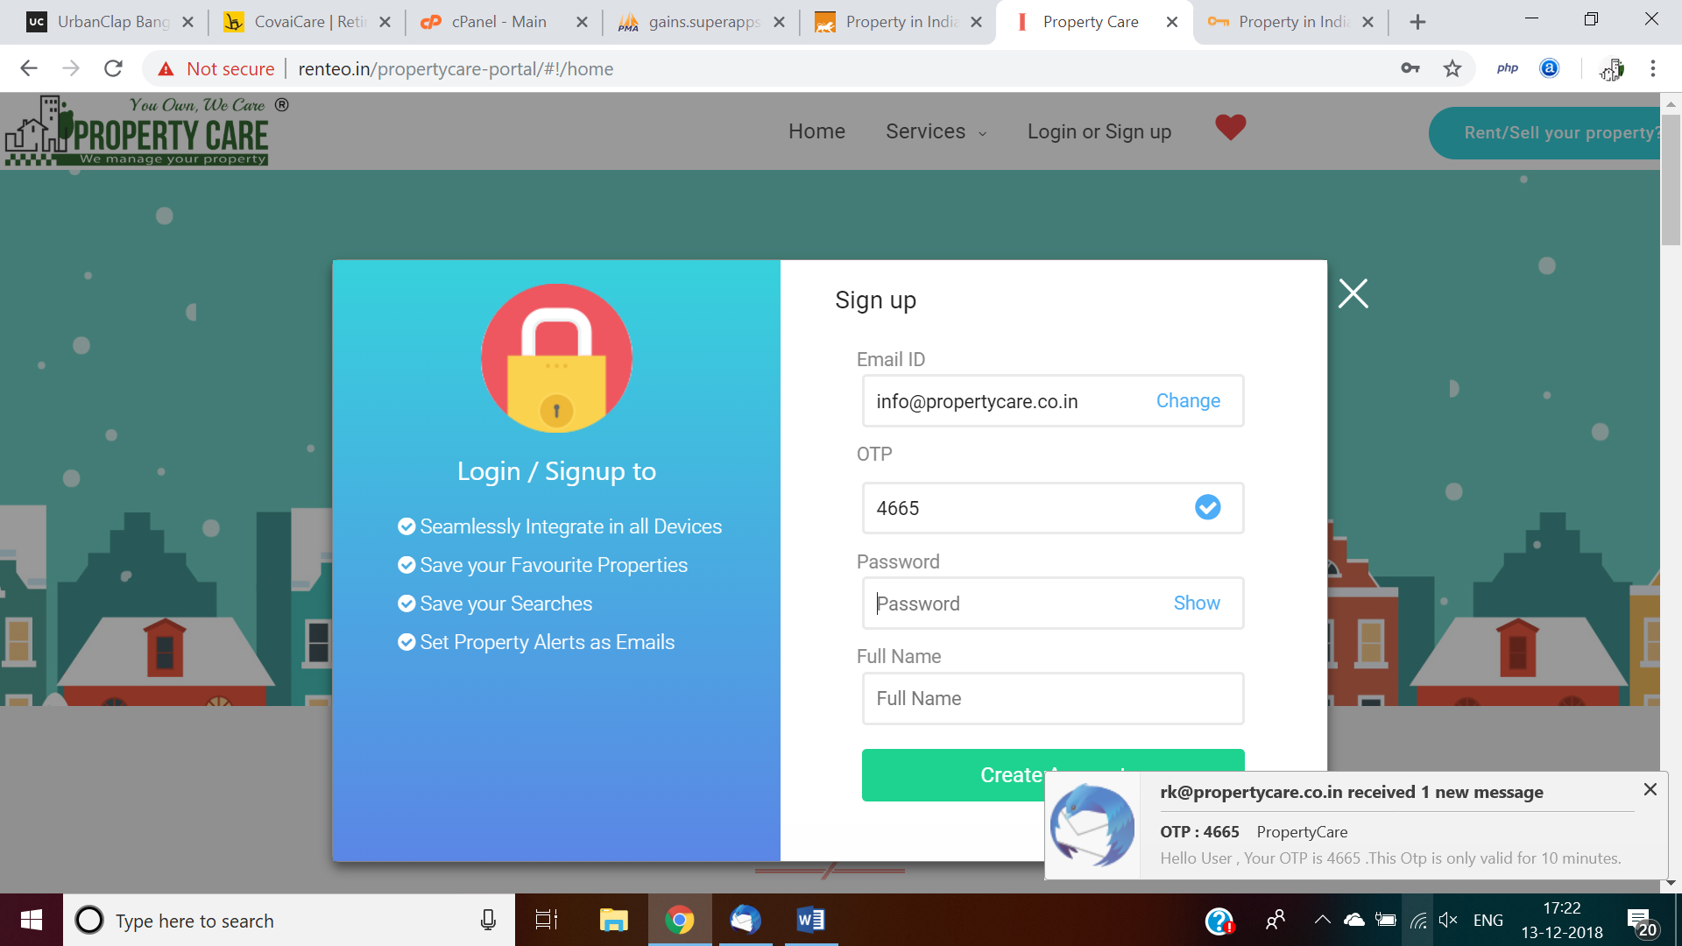  
         Mobile number capture format

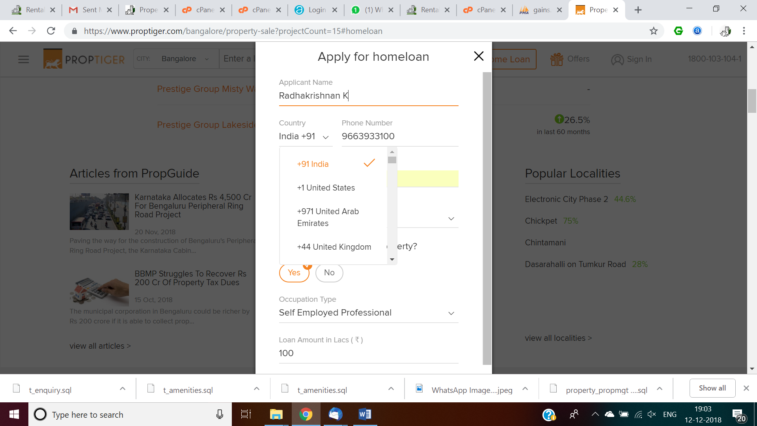

* 1. Professional animated video for
     1. Property management  
        
     2. Vacant site management, sample videos, photos available with us
        1. Compound wall construction
        2. Site cleaning and management
     3. Other service – Buy, Sell, Rent, Property Insurance, Katha process service
        1. Miscellaneous services - Katha process for entire society
        2. Katha transfers
        3. Property Tax payment
        4. End-to-end ie loan process, GPA execution, lawyer referral, legal support to lawyer, sale agreement, Property Registration Support
  2. Links to
     1. Social media – Facebook, Linkedin, Instagram, Twitter and Youtube channel, all video upload should leverage youtube, pl keep it bottom last, refer ‘About us’ screenshot below

Property manager and can publish ad for new project market like 99acres.com and generate lead, leverage project, amenities table. All other than property manager ads should come under review and admin will review and approve then it should go live. Please refer primal email for entire project marketing, photo, video, broacher upload etc.   
  
Existing UI for Apartment project capture:

alert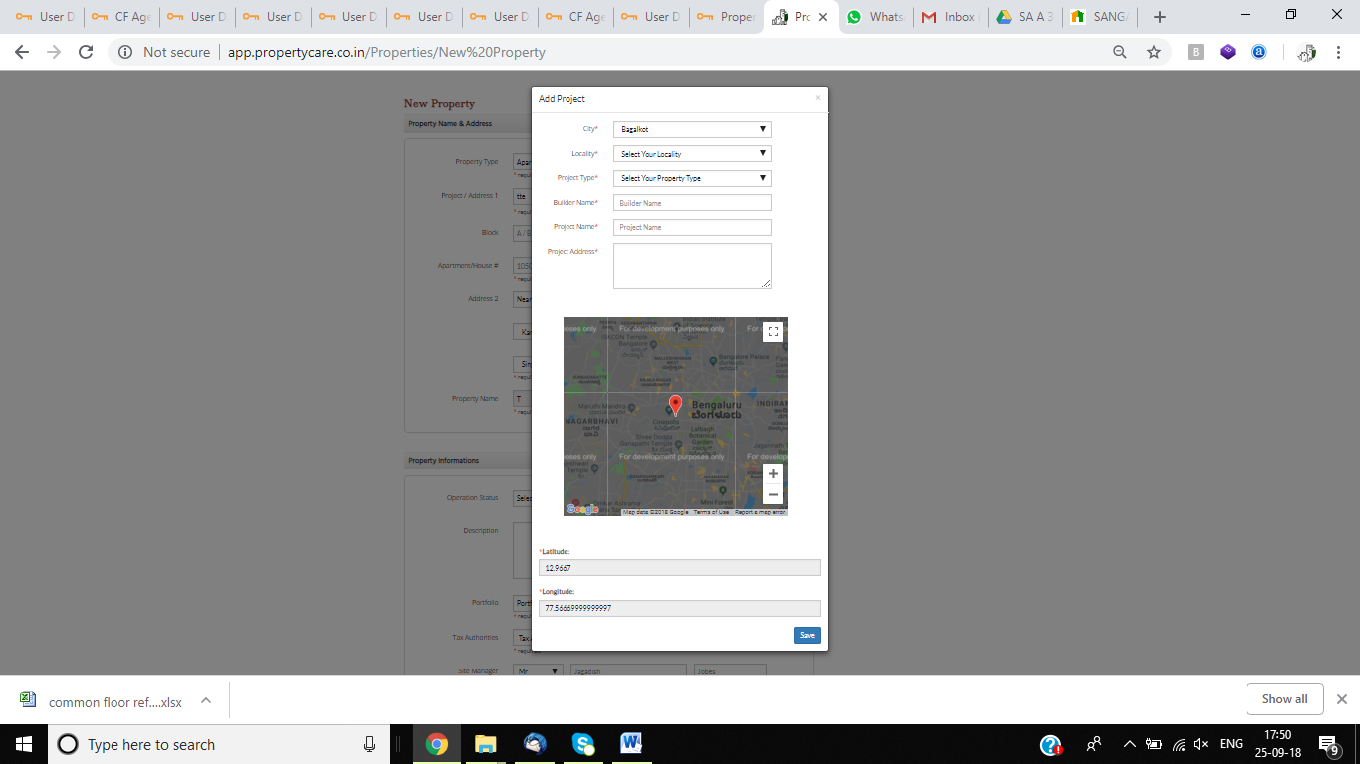

Post requirements with UI – Table structure already designed, leverage it, UI to submit and CRUD operation required in backend, all posts should go admin, property manager will review and approve then go live  
  
Existing: Franchise specific.

Wanted ad requirement capture screen:

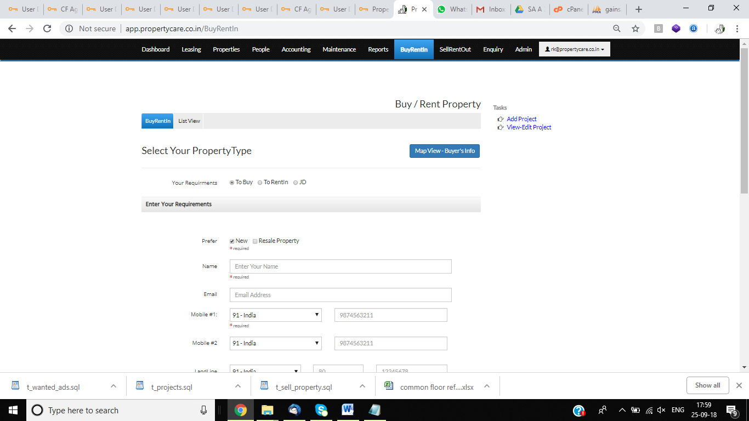

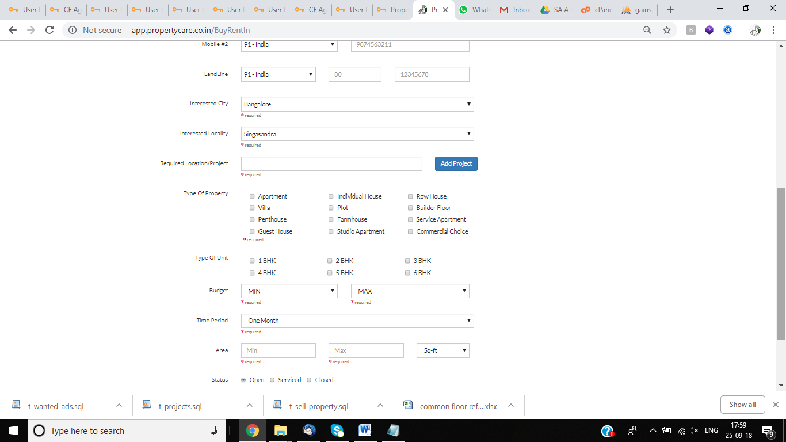

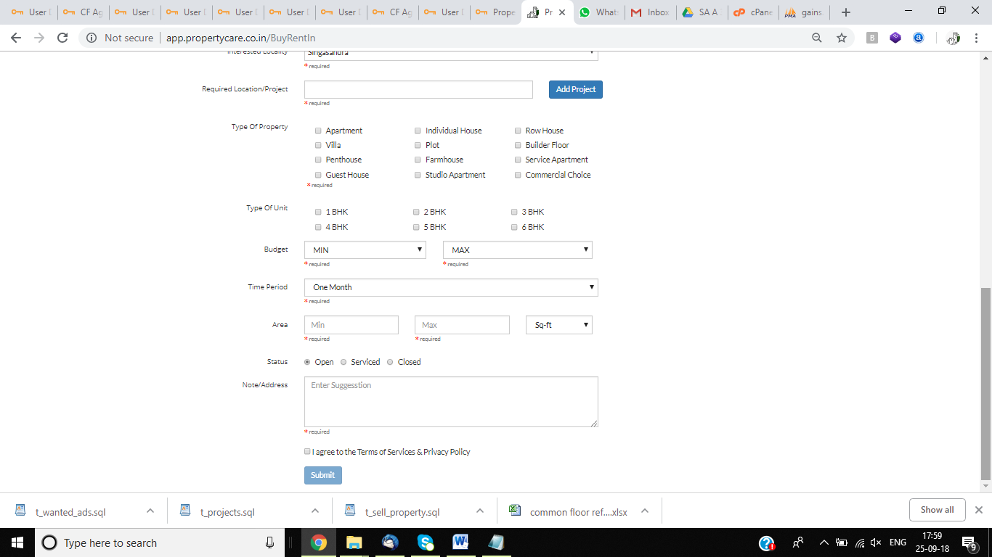  
  
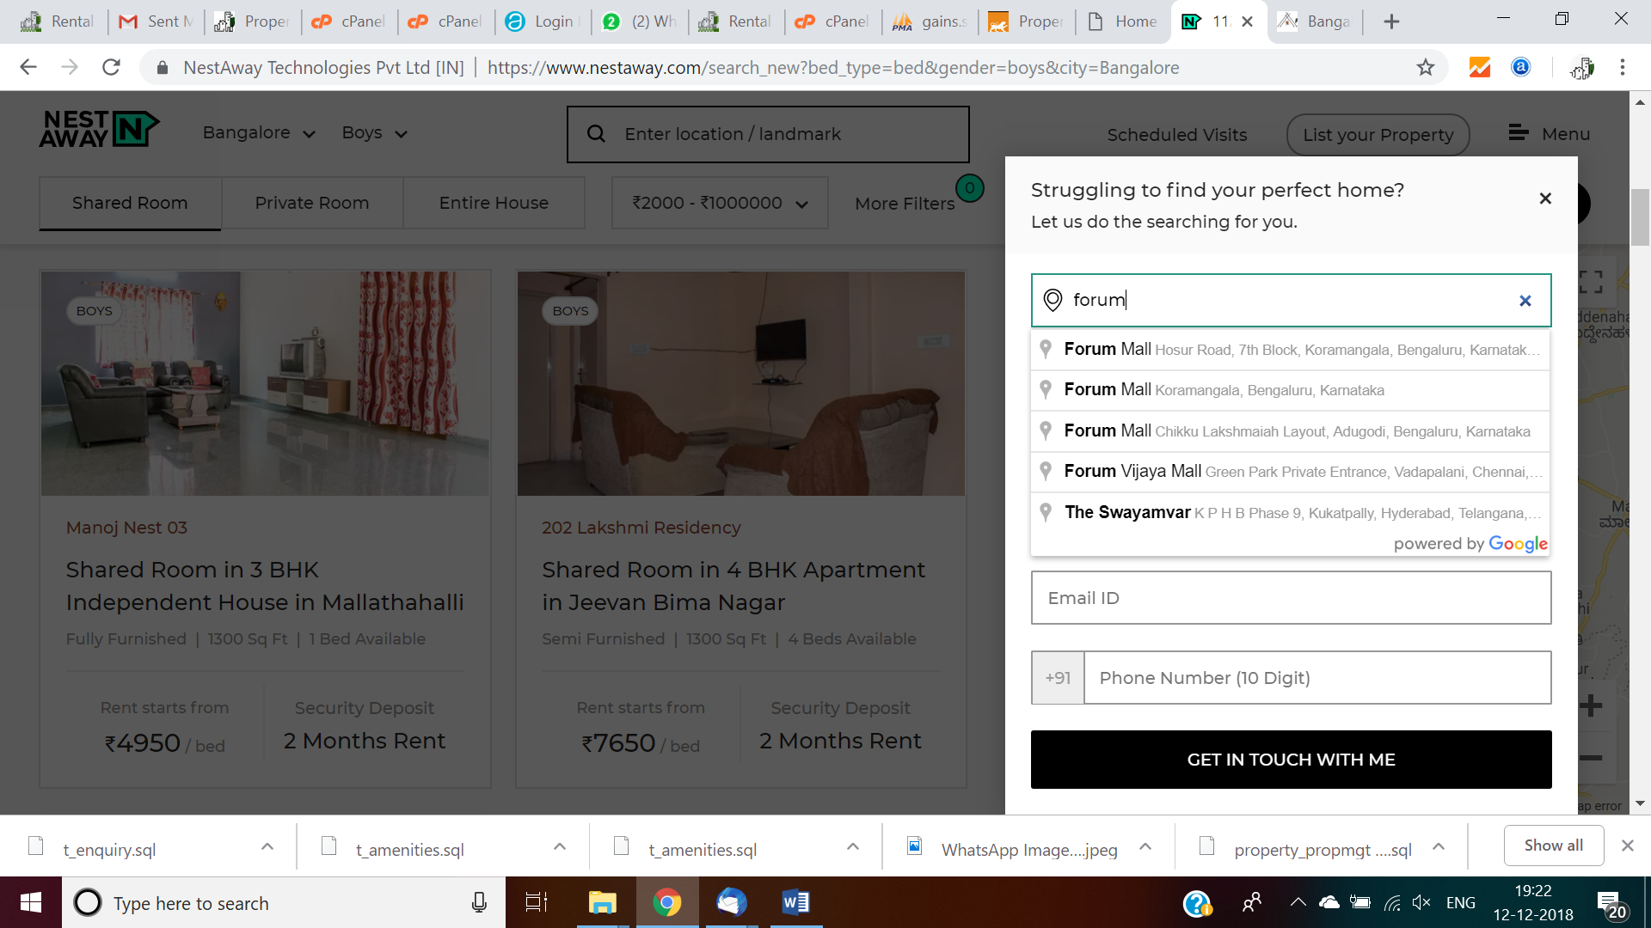  
  
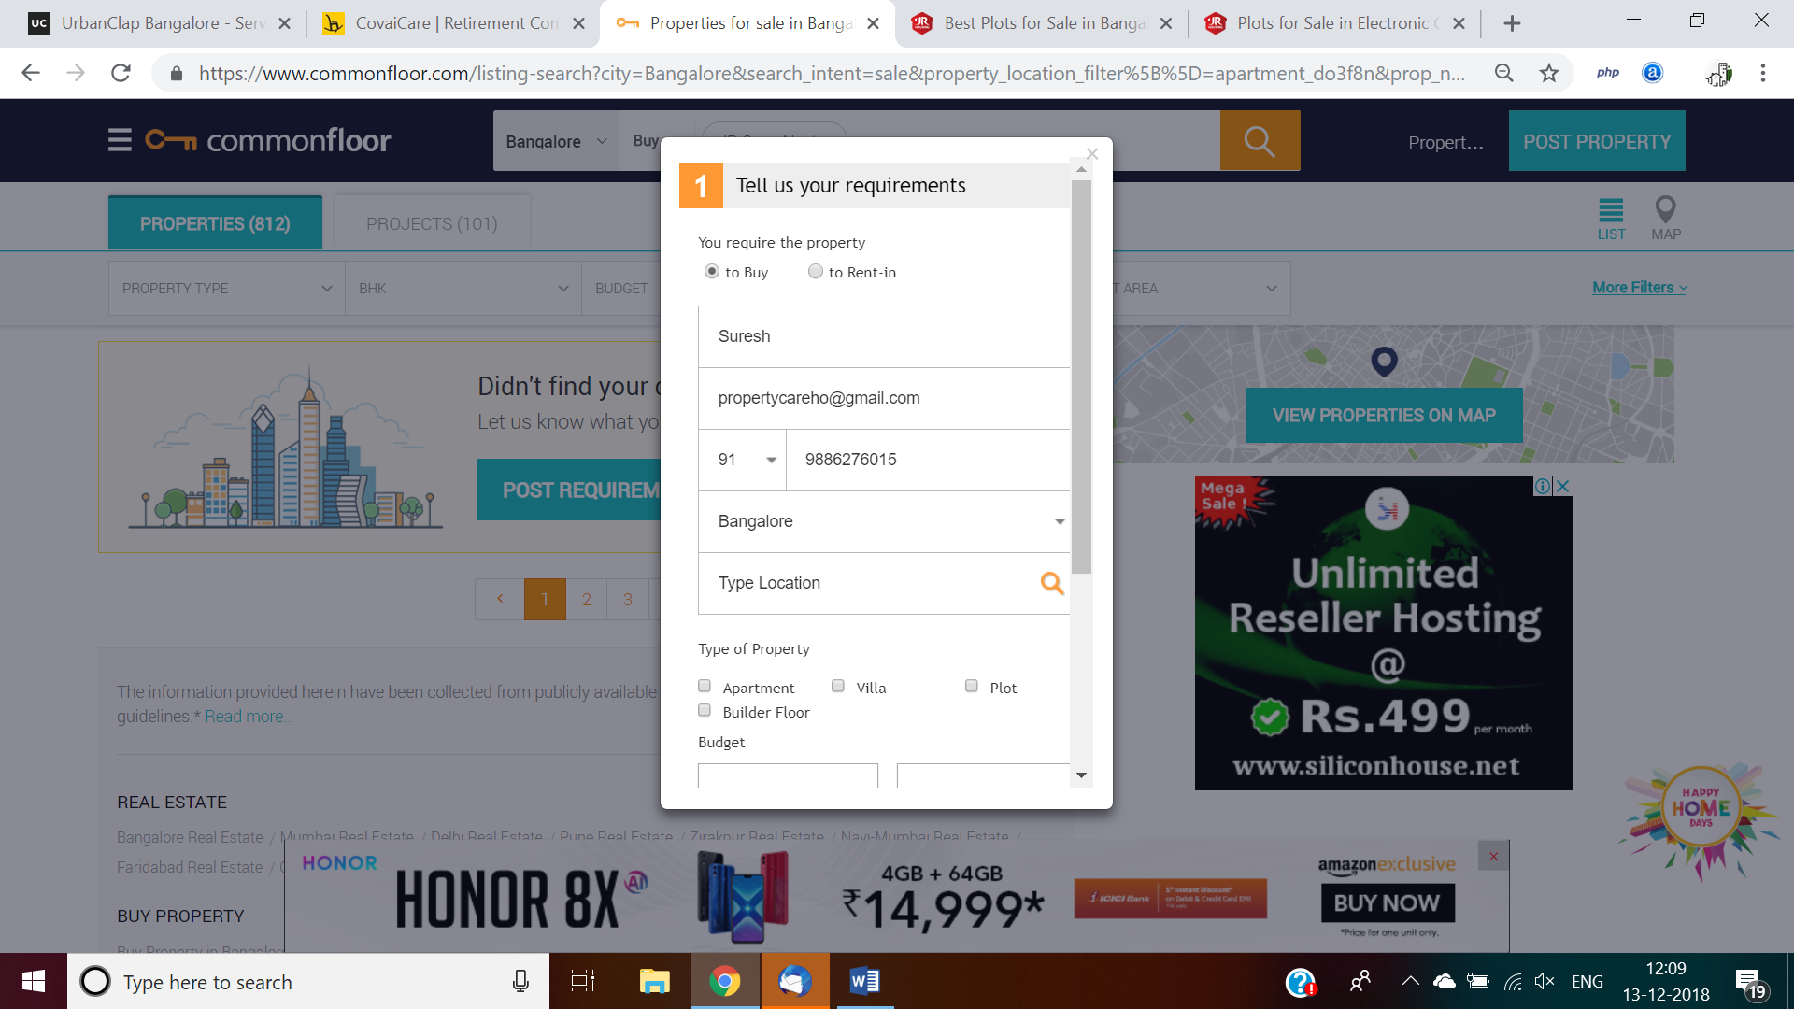  
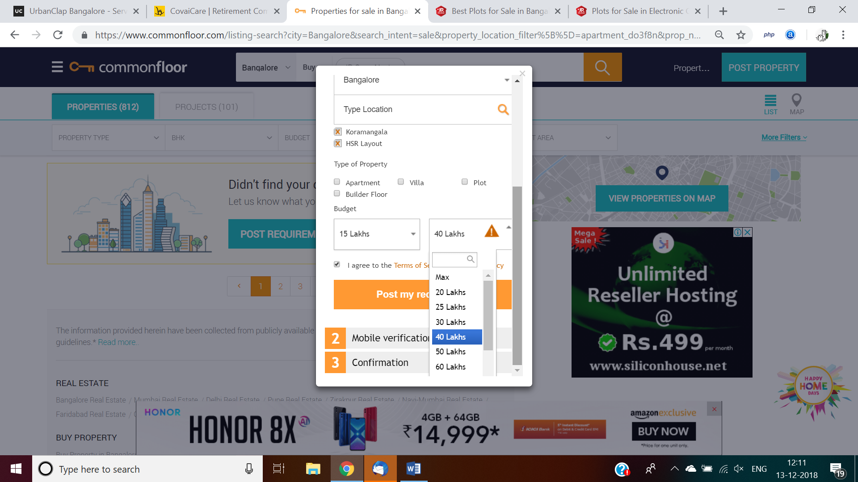  
capture with radius from map location, example is there in urbanclap.com

* + 1. Enquires from contact us page, leverage t_enquiry table, minor tweak required in this table, UI to submit and CRUD operation required in backend, all posts should go admin, property manager will review and approve then go live, like CRM tracking required with necessary statuses.  
         
       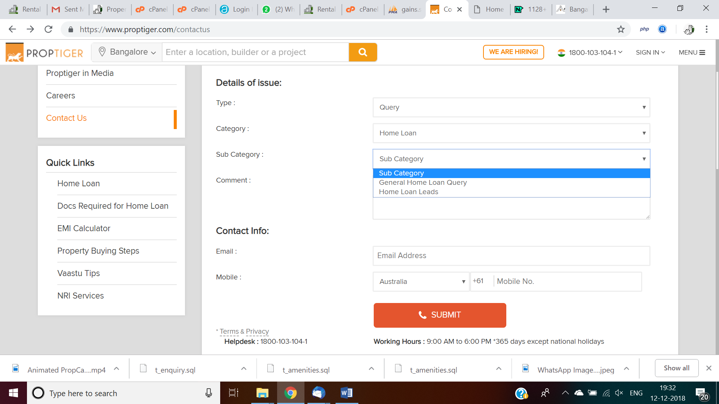
    2. Lead responses for listed property, leverage t_enquiry table, leverage contact us UI to submit and CRUD required in backend, use ‘Request call back’. SMS message to be evaluated, email required to info@propertycare.co.in  
       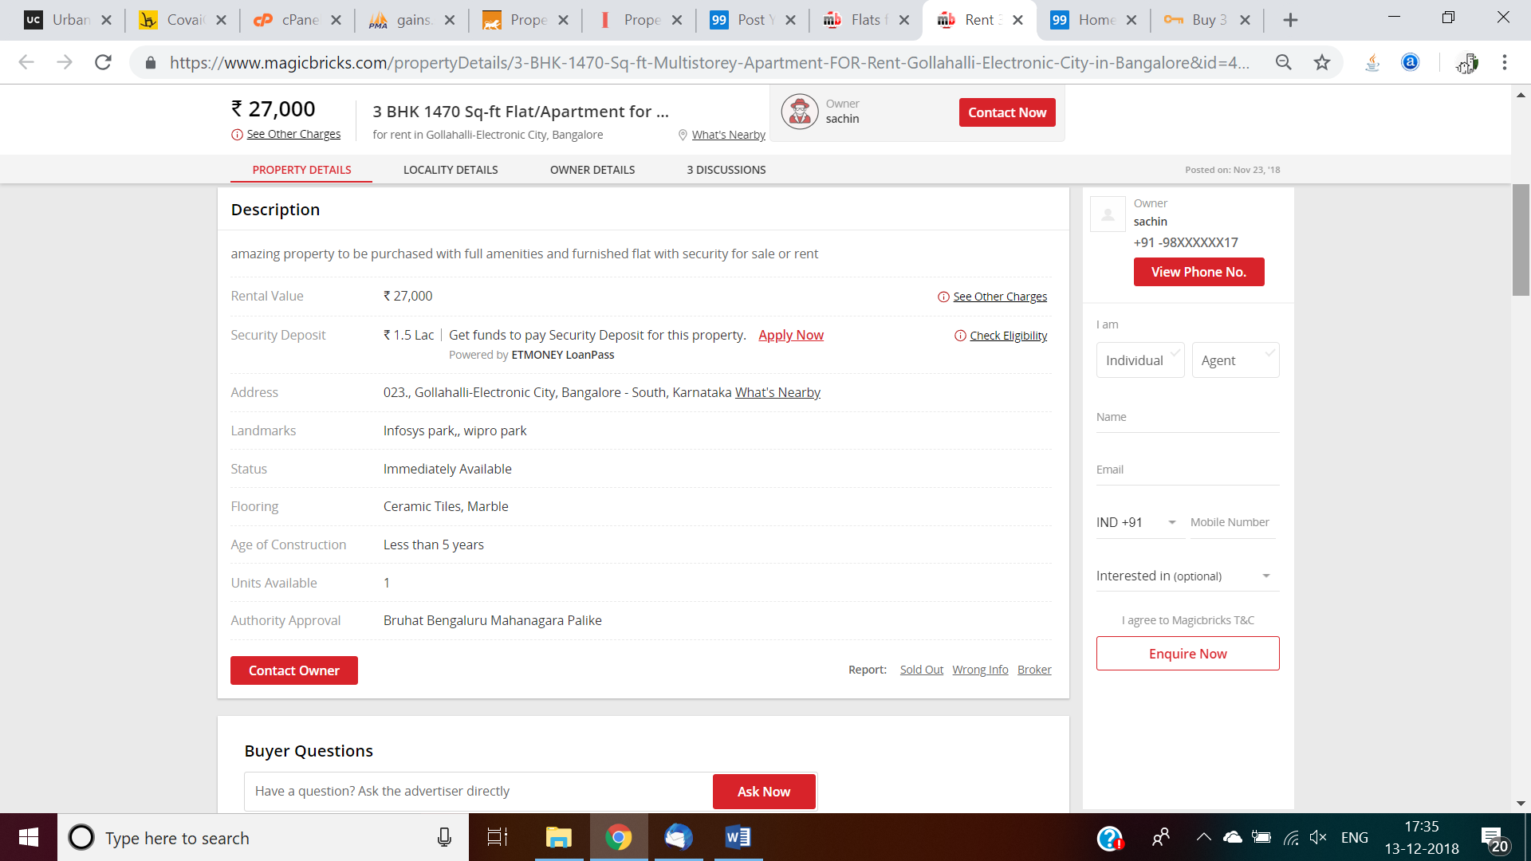

Post Rent, Sell, Joint Development properties by Owner remotely, office, stalls and map view in portal and mobile with search criteria and upload photos, videos with exact map co-ordinates, locations, UI to submit and CRUD required in backend, exisiting UI  
  
New property offer:

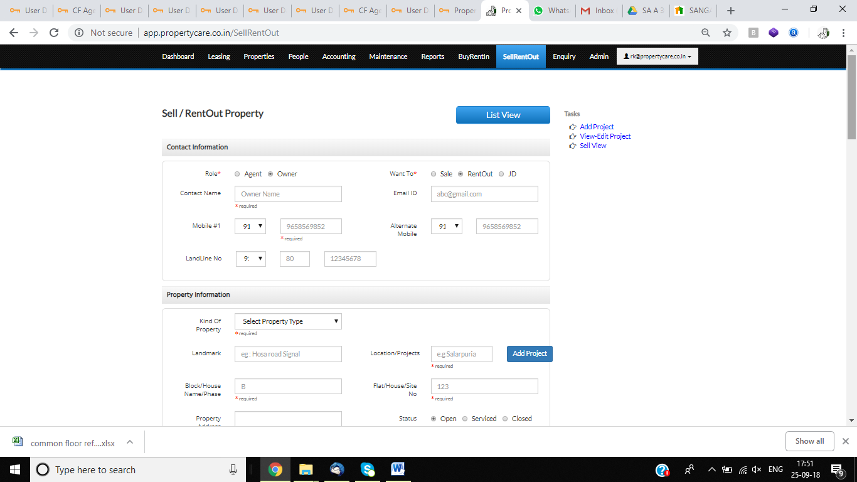

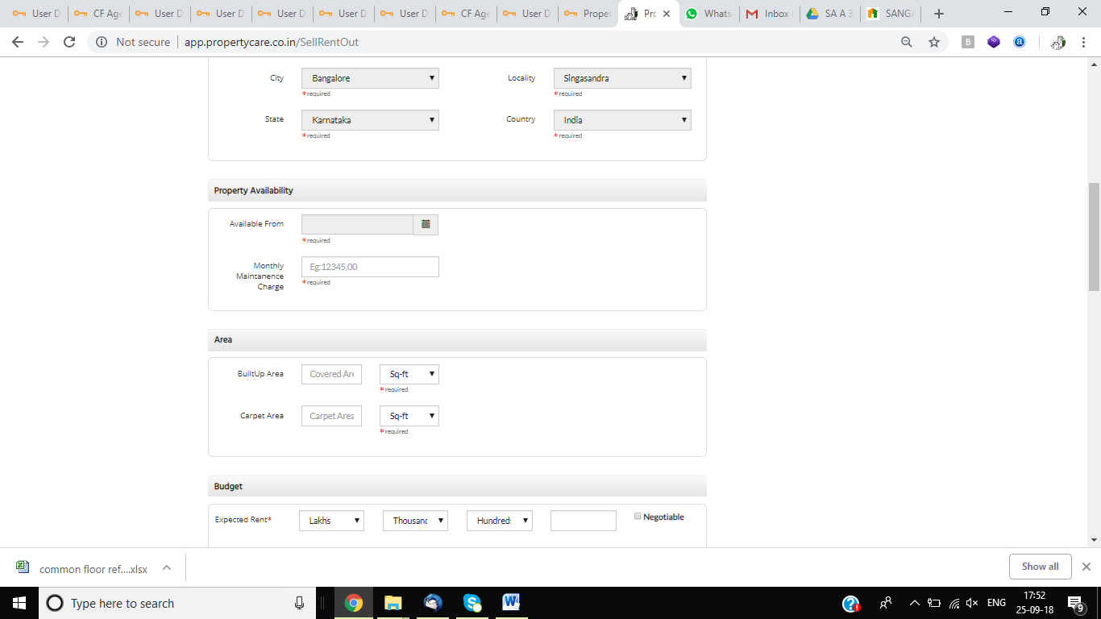

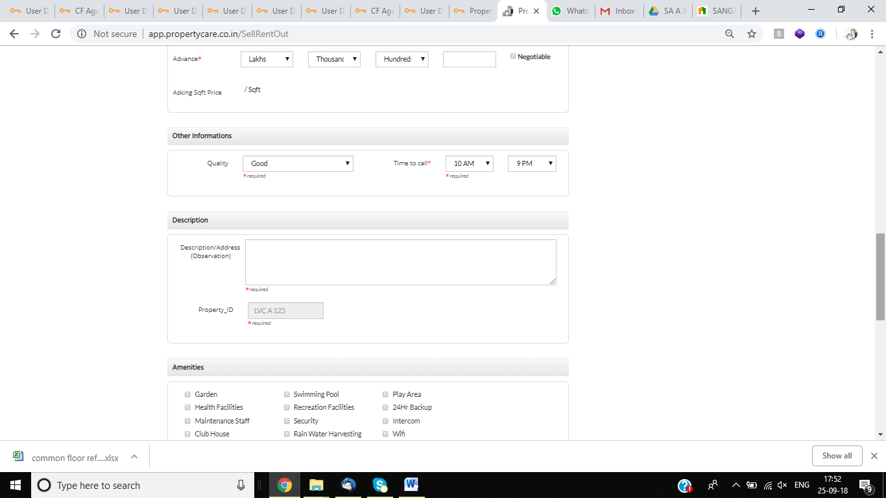

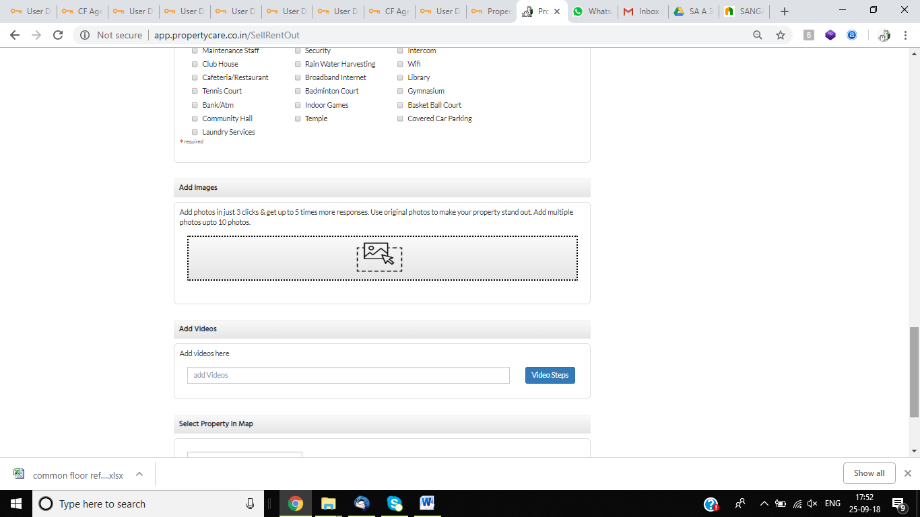

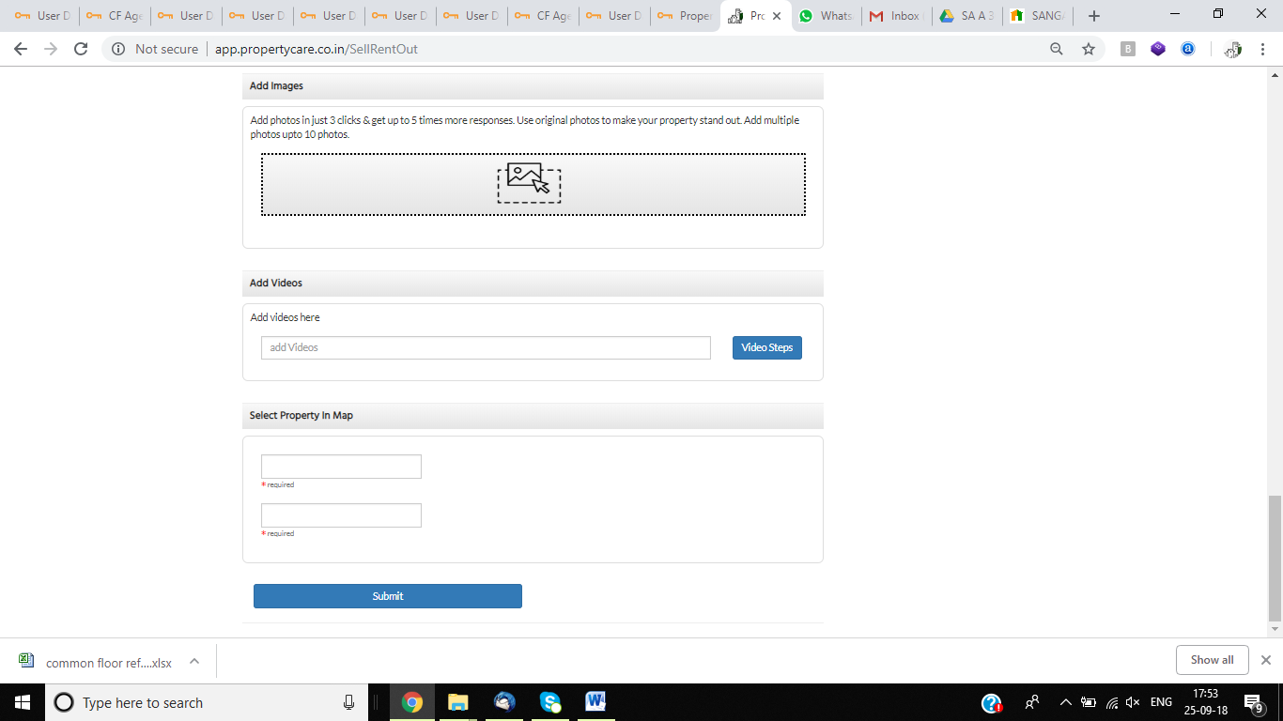

Table stru for above screen: 

* + 1. More than one property at same location should show with legend as

https://www.proptiger.com/maps/bangalore/property-sale   
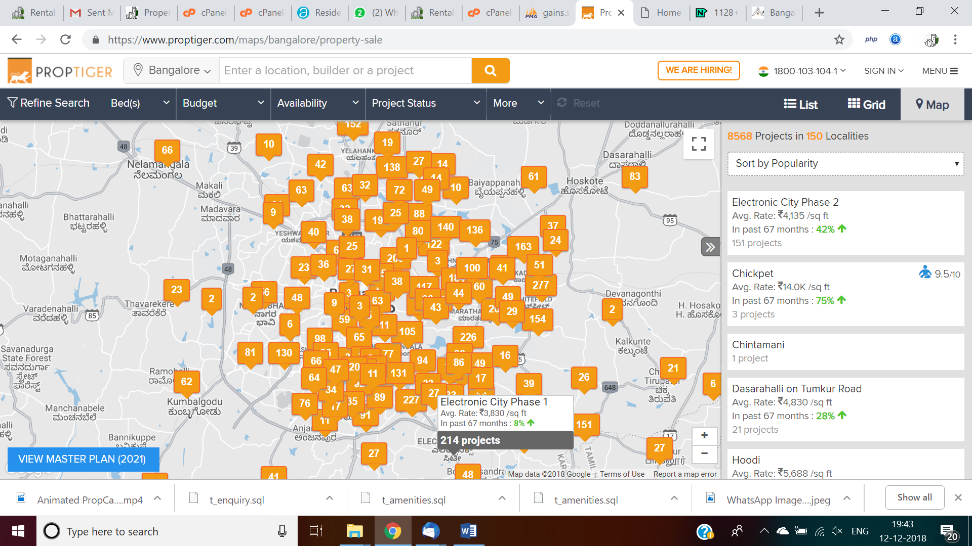 https://www.proptiger.com/maps/bangalore/property-sale-electronic-city-phase-1-50186  
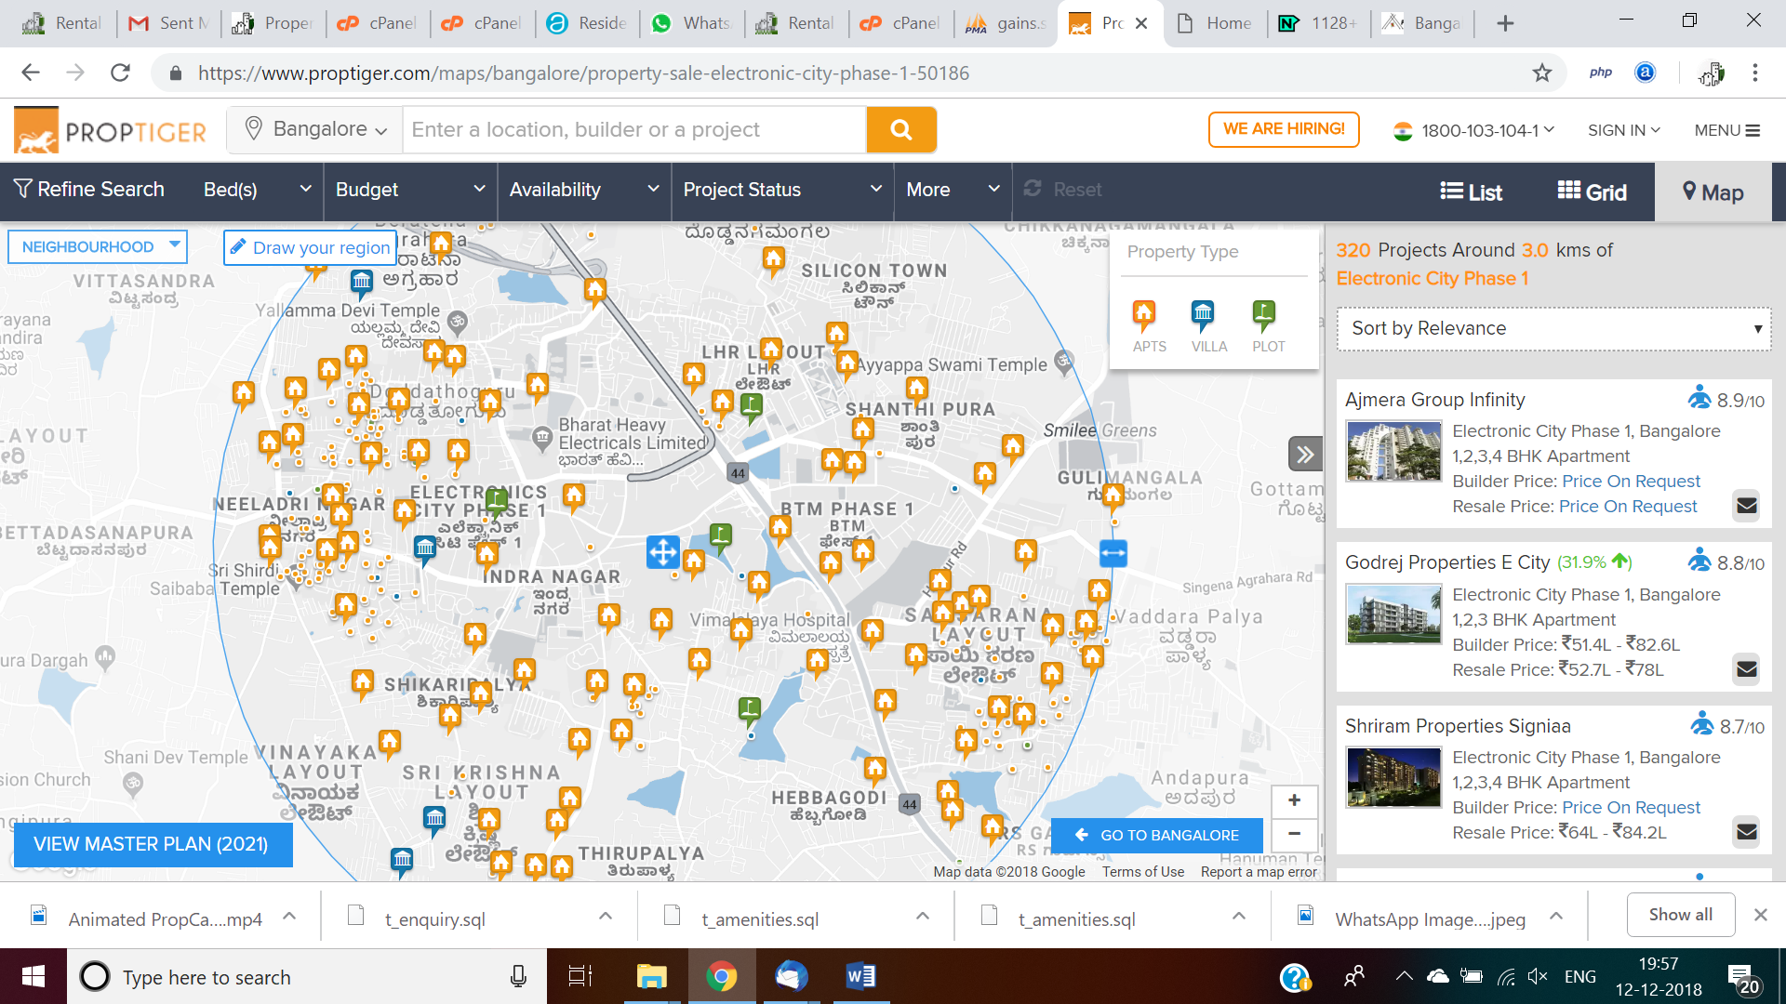

* + 1. Builders to enter their project details and upload photos, videos, only reference address should be stored in db, just invoke required in our application, no video loading into our server, this may reduce future performance;   
       List view sample look and feel : <https://www.proptiger.com/bangalore/property-sale?projectCount=15>  
       same data in map view required, builder project additions UI columns verify in this site.  
       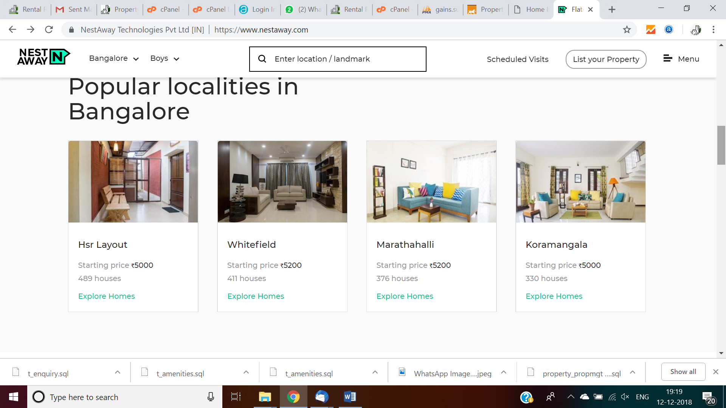  
       show case 4 project images like this in home page.
    2. Post sell/rent properties by owners, provision required to upload photos with display image [check box for 1 photo] List view sample look and feel : <https://www.proptiger.com/bangalore/property-sale?projectCount=15>  
       same data in map view required, builder project additions UI columns verify in this site.
    3. Vision text
    4. Infographics for

Property management process  
sample for idea: Revenue generated from locked flat, Flat letting, Management and end-to-end service for owners and tenants, Vacant site management

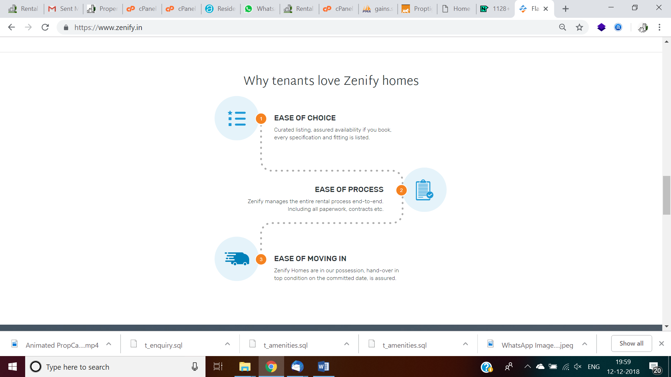  
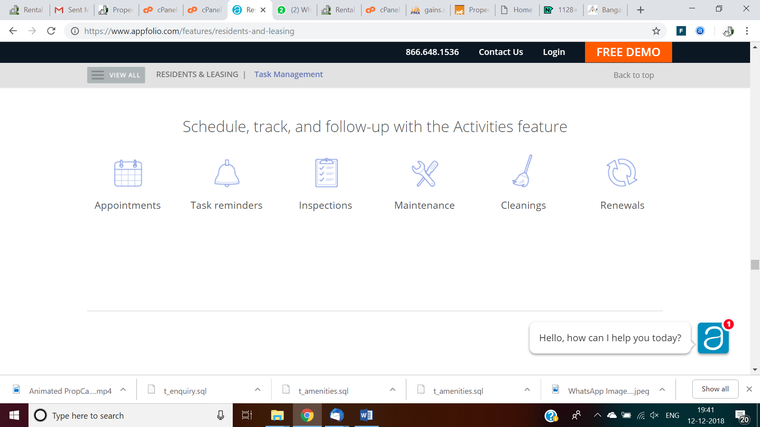

* + - 1. Vacant site management process
      2. Corporate employee benefits
    1. Get home loan link, leverage enquiry table with flat for loan; lead for loan  
       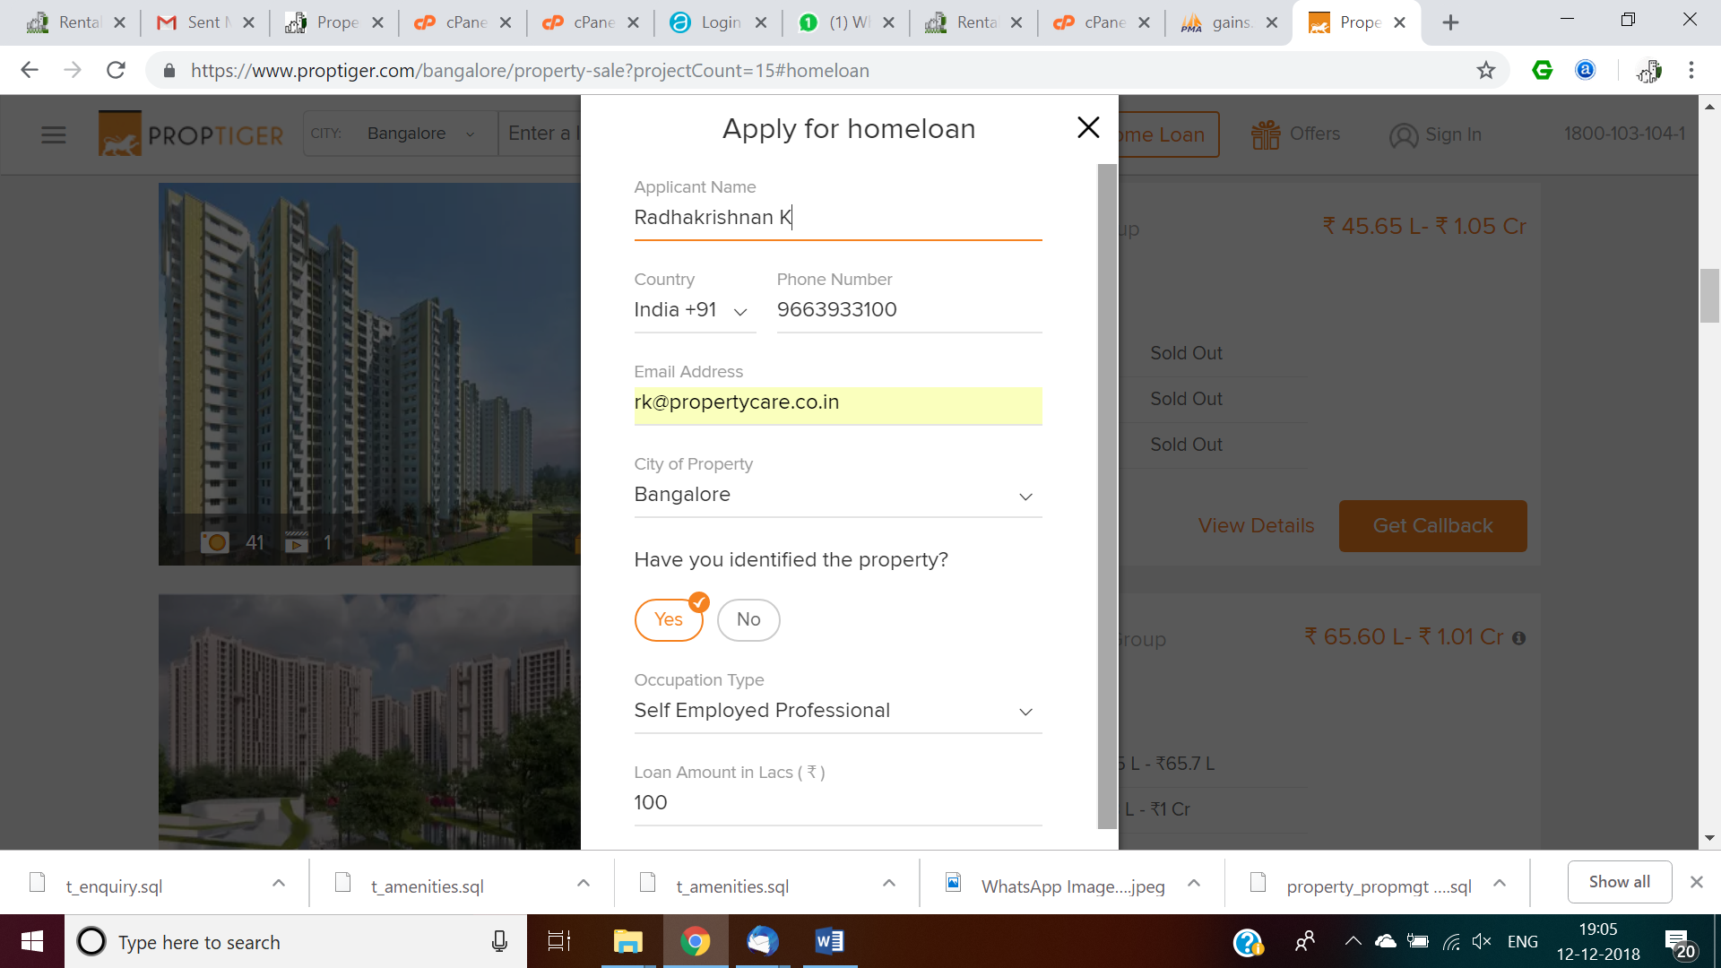
  1. Get home Insurance link, leverage enquiry table with flat for loan; lead for loan  
     http://home.policybazaar.com/?utm_source=organic  
     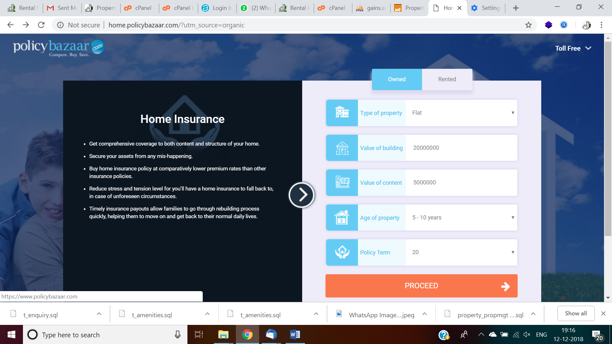  
     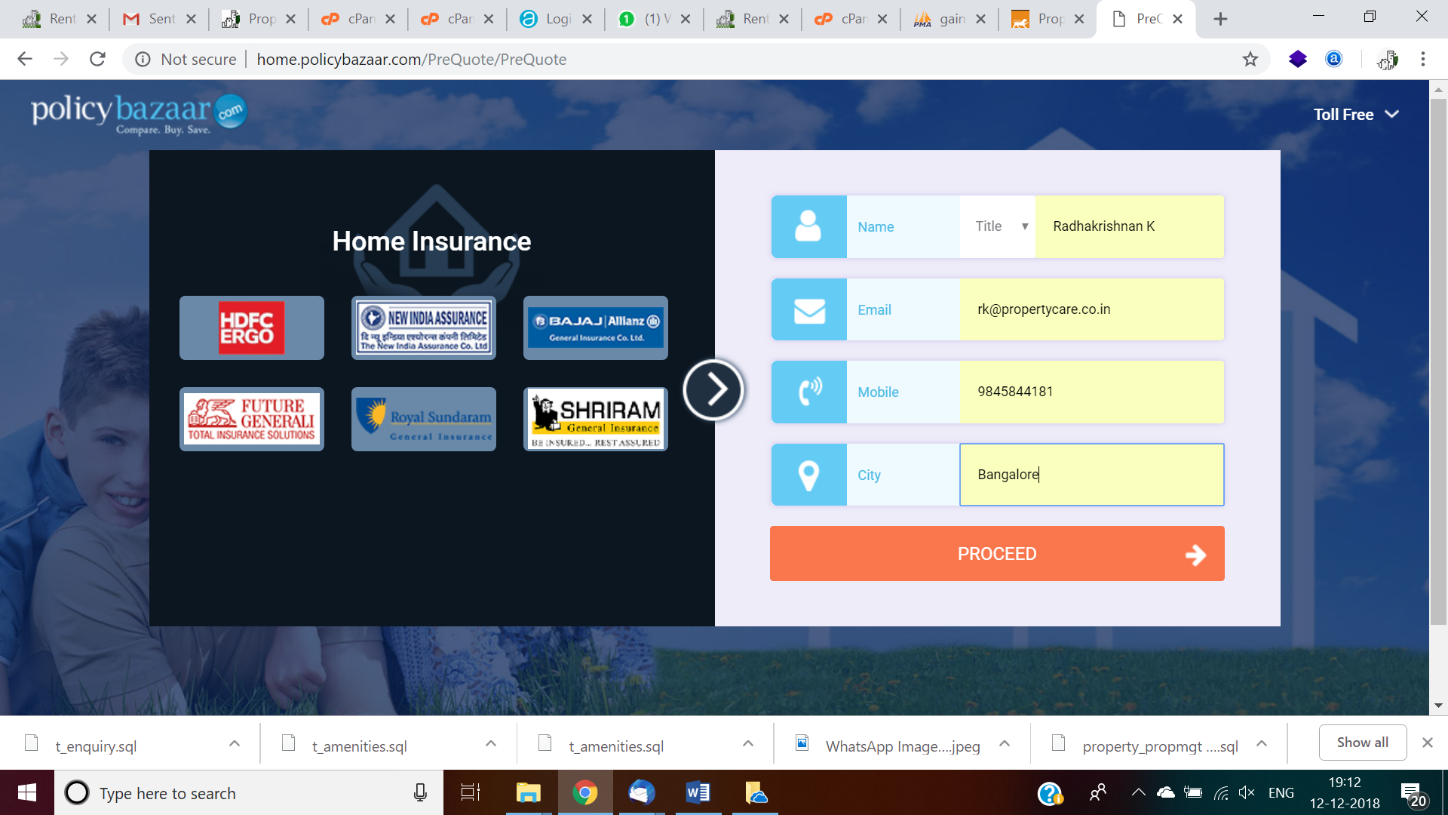  
     Include about us text, sample given below, few in propertycare.co.in available  
       
     1. Offer help, chat screen once home page is launched, both online and offline options required
     2. All location identification for users to publish ads thru google map, and clicks on the preferred location. For example: Apartment project location identification for builder, show map and user will click on the location and take google co-ordinates and store in db
     3. Provision required for photos, video upload for all properties, store reference link only, add up and show in youtube channel/amazon s3 bucket.
     4. All listed photos slideshows, and video run should be enabled in 32-inch touchscreen TV at office for visiting customers to view properties, hope tab enablement is fine to meet this requirement
     5. Portability required for future property upload in commonfloor.com, 99acres.com with browse button, select path and file of excel file and upload into their system instead of retype again, saves time. Export option of listed property, interface.
     6. Publish wanted, buy, sell, rent property ads with whatsapp photos, video on mobile
     7. Search criteria on home page, keep it top like this  
        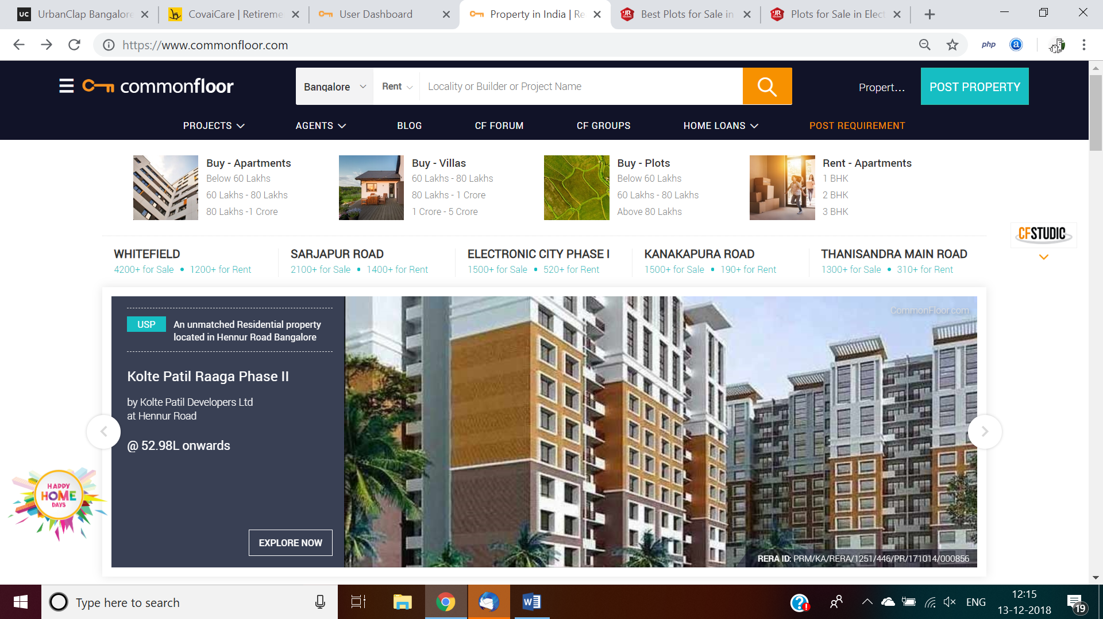

Additional features required like this   
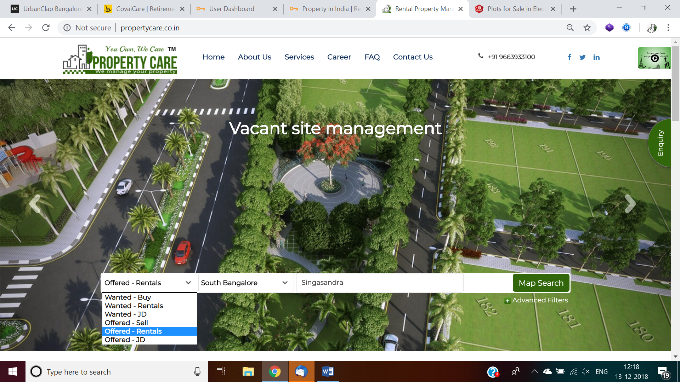add check box in dropdown with option to choose one or ‘All’, franchise also choose one or ‘All’, default all, all drop down sequence business user will decide, use t_parameter table for dynamic data pick up for auto populate, any addition use should be able add and automatically should come in popup, no hard coding

should be used.

* + 1. Testimonials/feedback sharable link required to get feedback.... if high rating in our portal then google reviews also required, pl chk big cos how they handle both, latest solution required
       1. During testimonial capture, show photo click and self-video capture option for max 2 (configurable) minutes, multiply minutes x 60 sec show seconds count decrease one by one, send to admin/moderator review and approve and publish in youtube. Should be displayed like this <https://www.youtube.com/user/appfolio>
    2. Market property in same community itself, market template and whatsapp interface, owner can circulate this to their community. Each property ad should have ‘share icon’ ‘<’ shareable link, and create short link option like bitly, need send give send message to owner’s whatsapp no to circulate in their community and other interested lead to video property photos and video, now we are sending through whatsapp for every prospective tenants/buyers. Use ‘heart’ sign, ‘save search’ criteria for frequent search to capture favourite/short list the property. Set property alerts by email for given wanted criteria to users, and circulate email daily and send till for 3 weeks or user login and set stop.  
       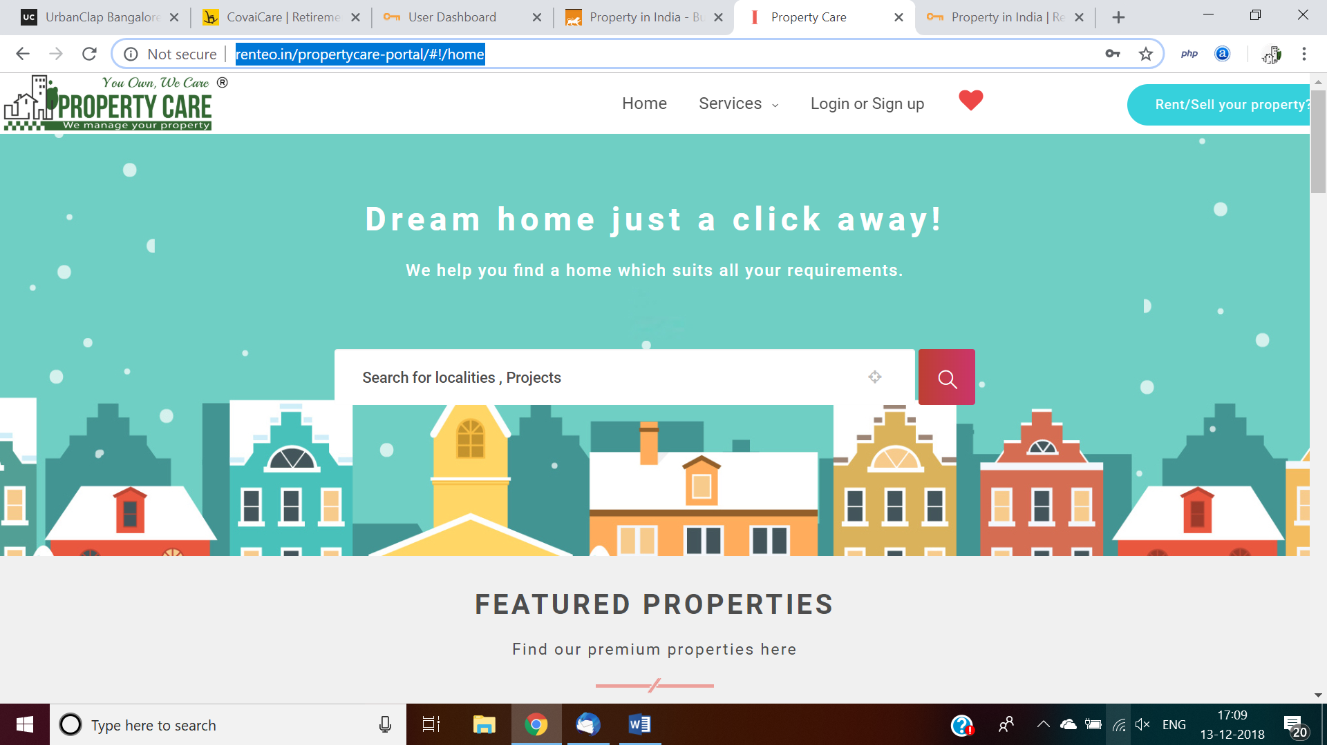  
       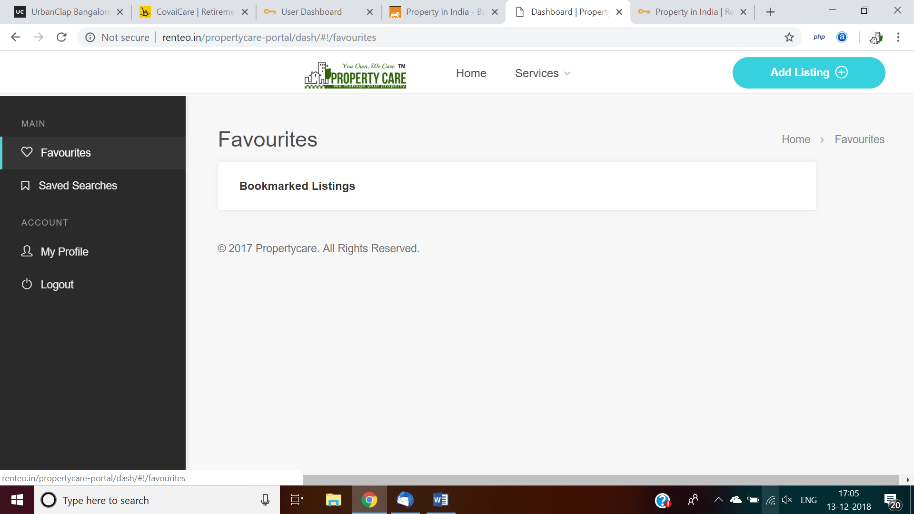  
       https://www.99acres.com/do/buyer/ShowBuyerForms/DisplayForm?p1=217&p2=R&p3=0&lstAcn=SEARCH&lstAcnId=0297412902503871  
       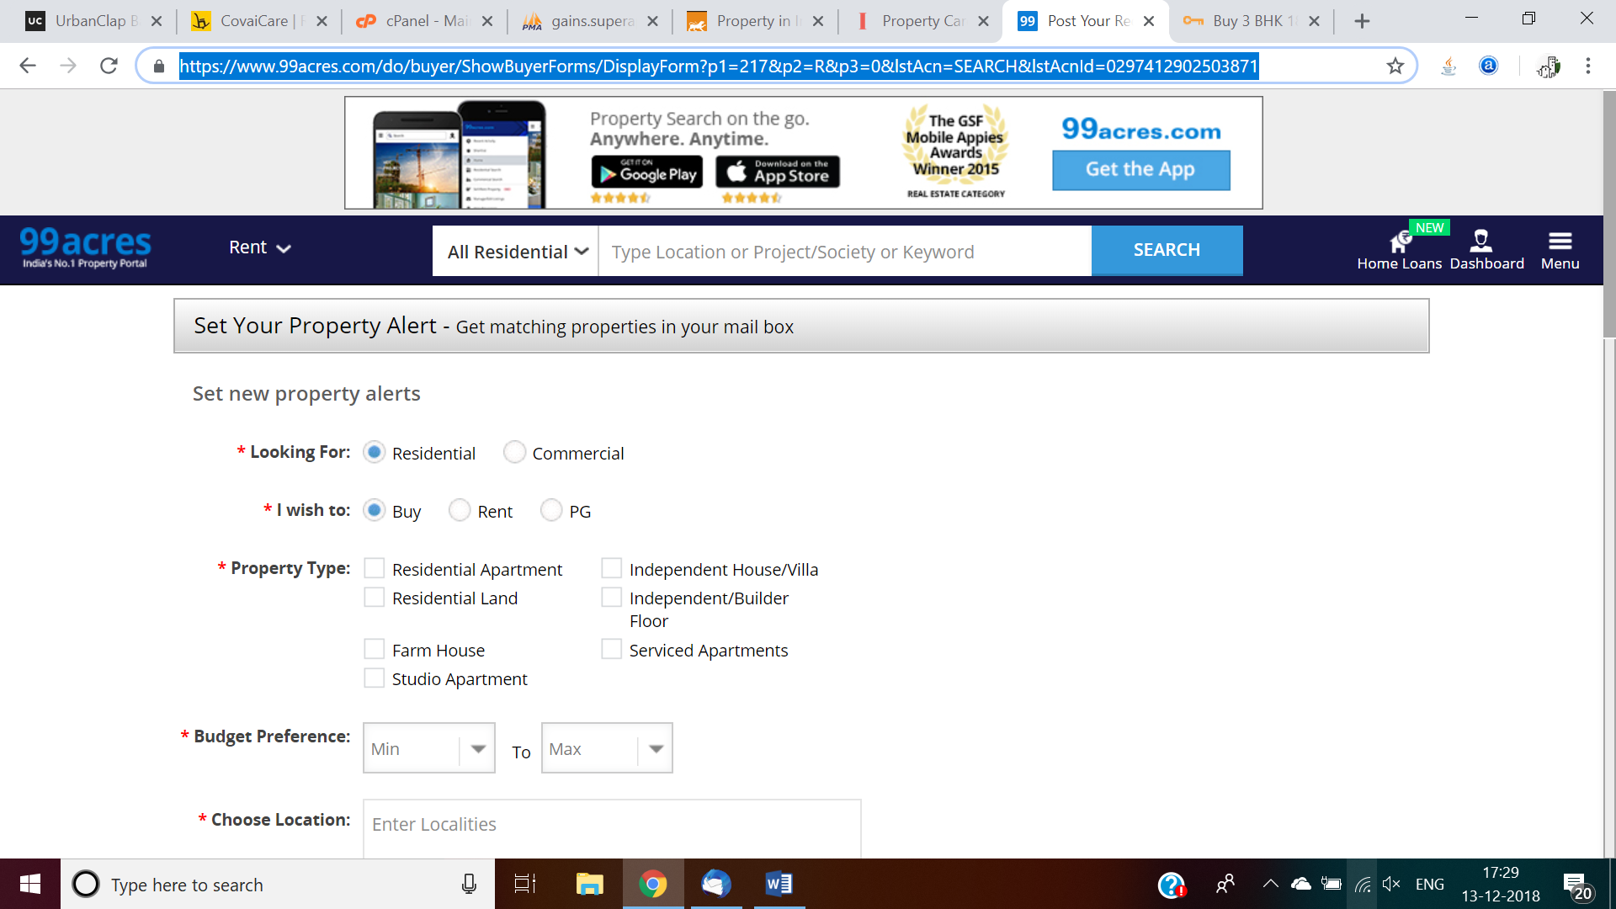
    3. Configure google analytics and provide necessary access for viewing site hits geographically.
    4. In mobile app/mobile site, apartment security should have option to pass leads coming to gate as wanted leads.
    5. Auto repost of ad, if ad days cross > 15 days old, set updated date to sysdate, like oracle trigger also ok or corn job, all ads should show how many days old and share symbol like <.   
       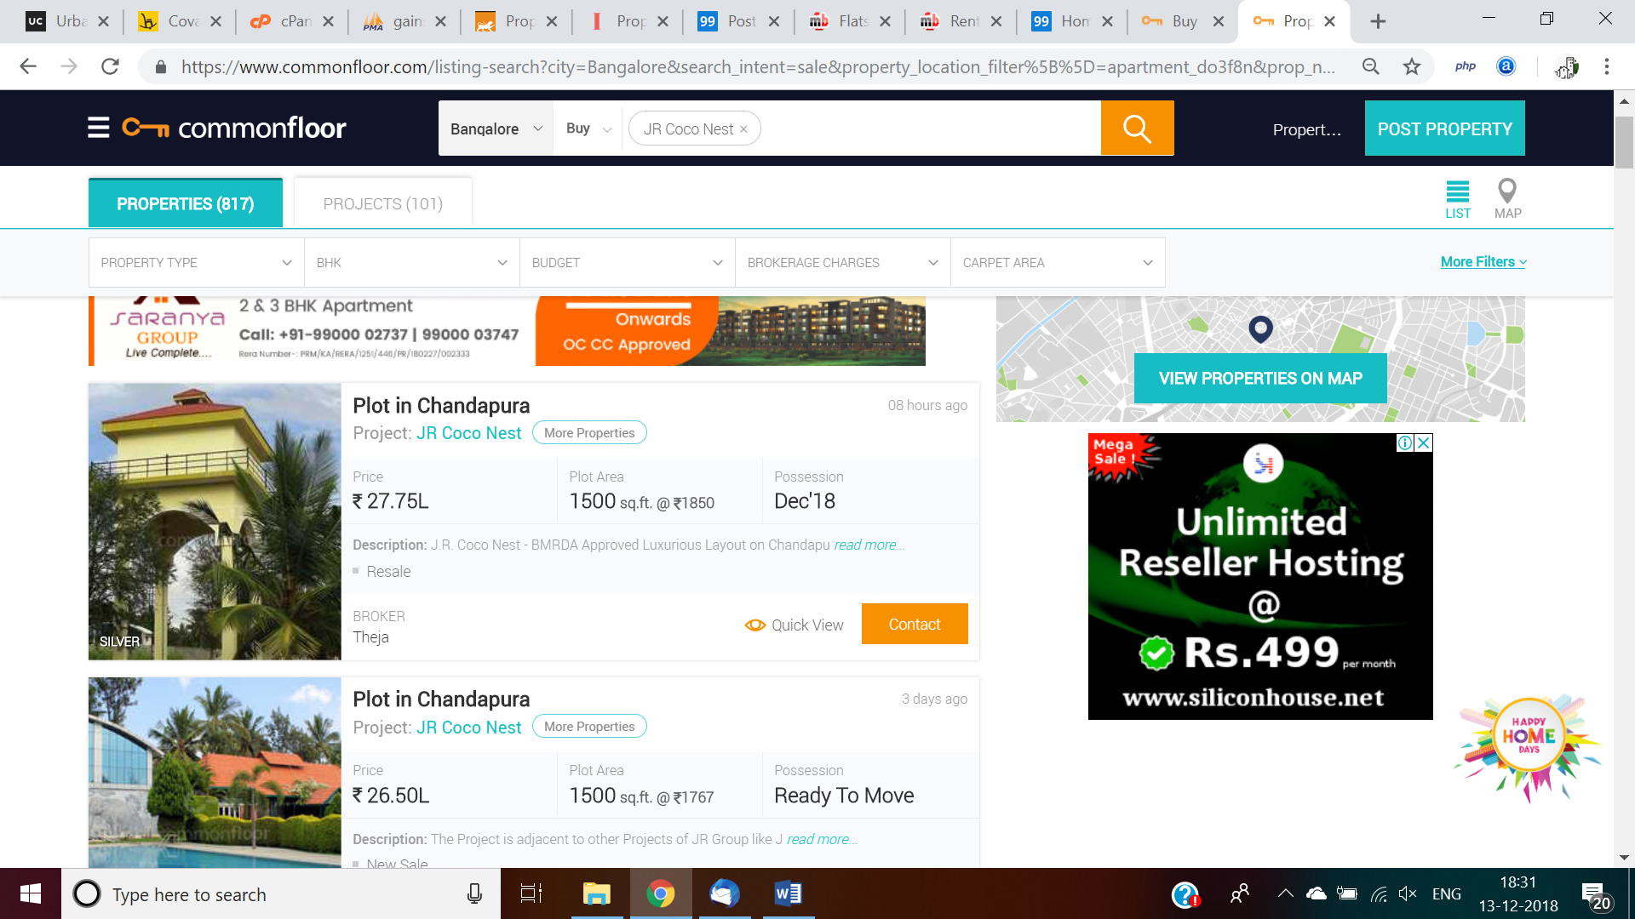

1. **Search Result page**  
   Existing: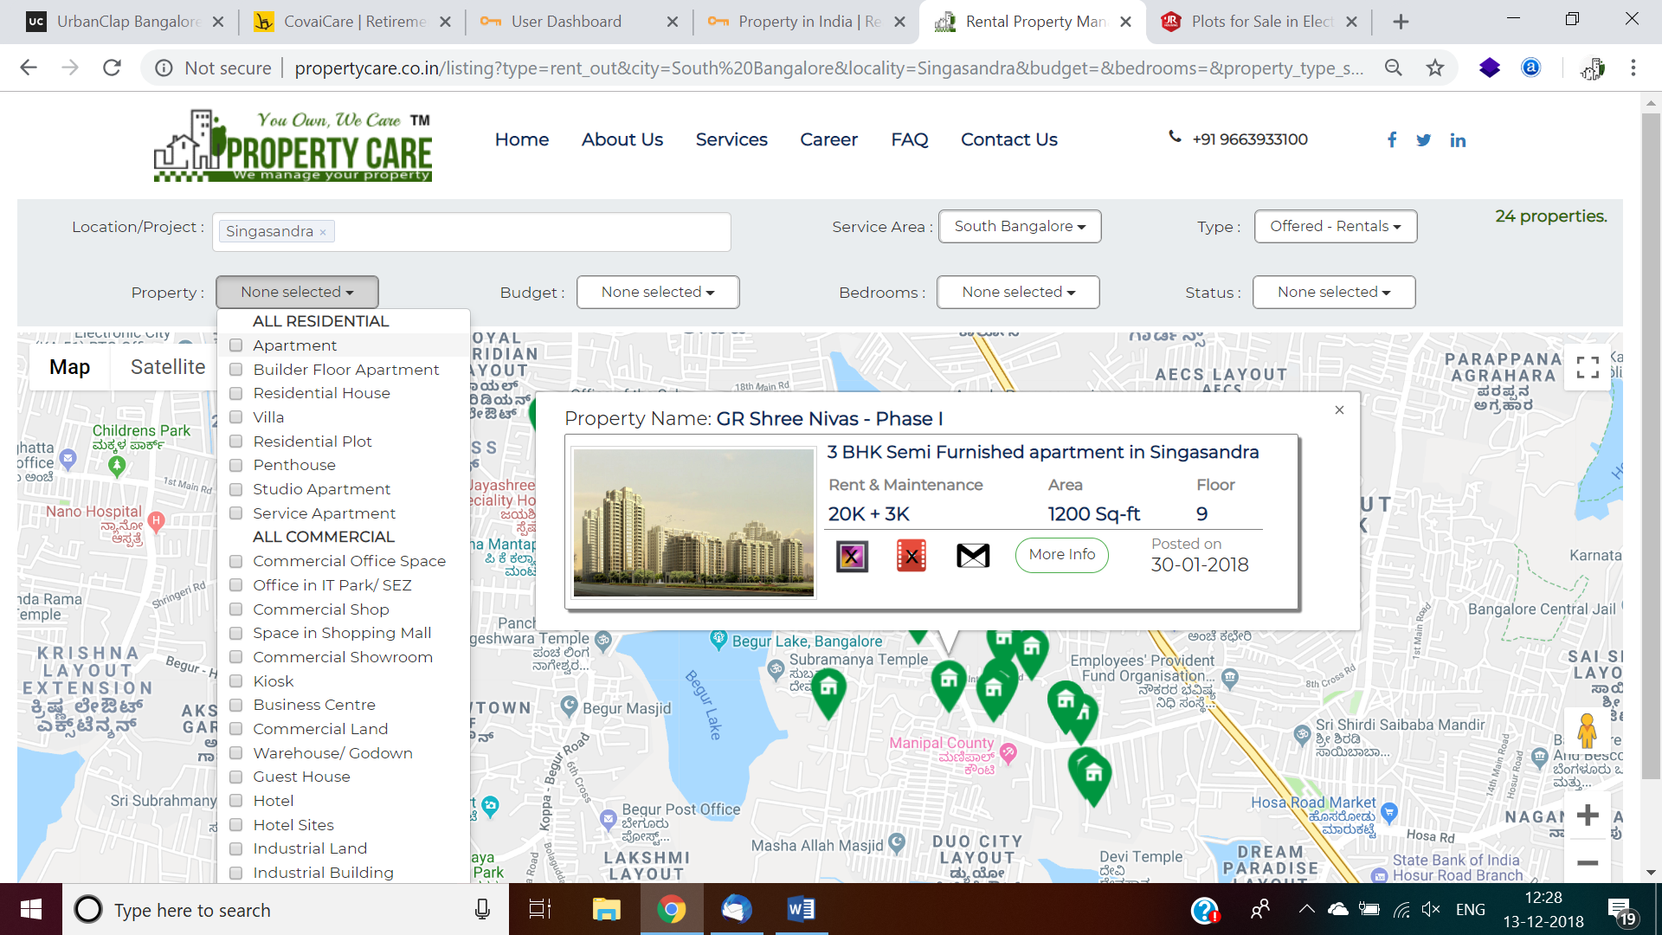Map view and mouse over popup is fine, list view and grid view options also required. If property manager logged in, can edit by right click and edit. Nice slideview and video run required from youtube, and capture interested leads data. If overlap on same co-ordinate can show total count, when user click on that show consolidated total list of properties in tabular format, mobile view also should be taken for easy viewing. Pl sample in proptiger.com; eg. One apartment, multiple flats management in same apartment, Lakeview county, 20 apartments ads need to advertise, and searching tenant need to see all available flat details.
2. **Services**
   1. Owner service, benefits, management, sell, vacant site management, a video clip with bullet points and info graphic image
   2. Tenant service, benefits, a video clip with bullet points and infographic image
   3. Investor, benefits, a video clip with bullet points and info graphic image
   4. Corporate, benefits, a video clip with bullet points and info graphic image
   5. Builders and Developers, a video clip with bullet points and info graphic image  
      Like below screenshot, hooking in home page also ok, 4+ years’ experience property and customer counts should run and stop like this. Numbers we will share.  
      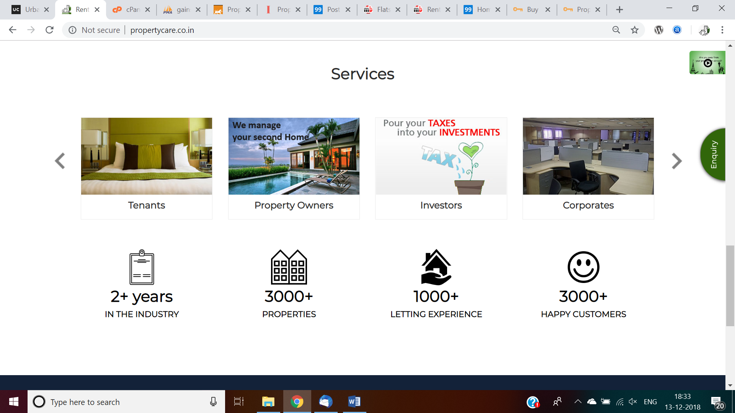  
        
      Leverage footer information   
      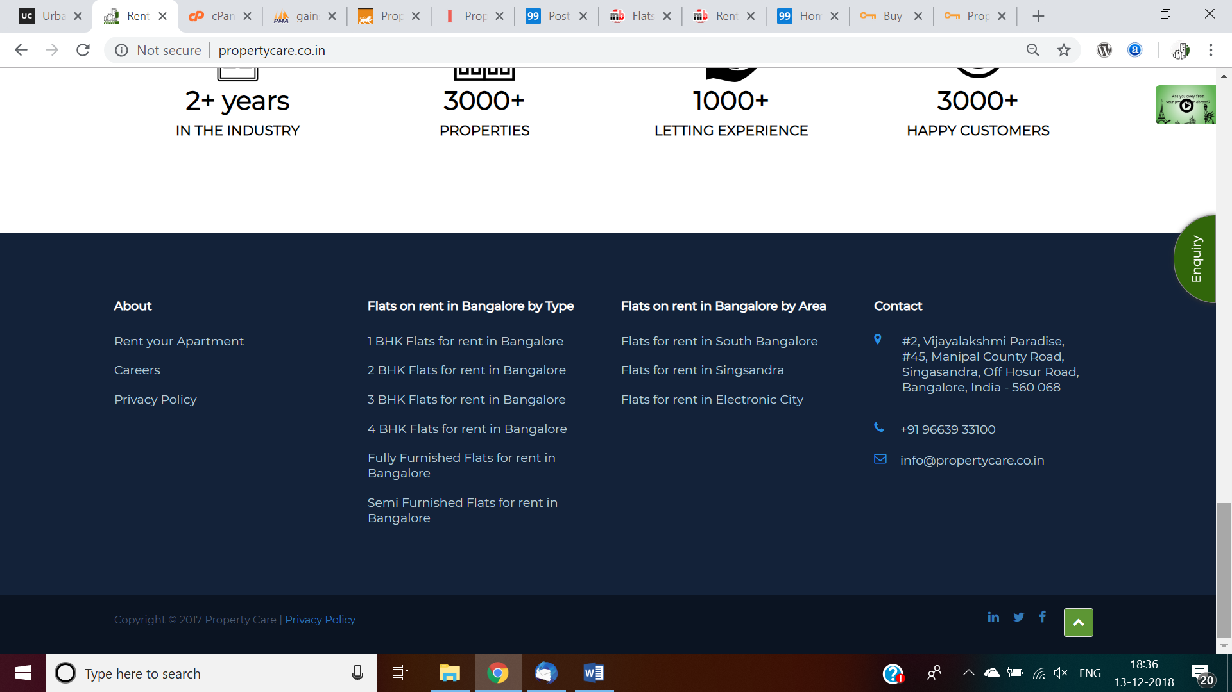

1. **Franchise Opportunities**
   1. B2B
   2. Video Franchise partner inviting to join our network and run same business in your location  
      https://www.poornaayur.in/franchises-of-poornaayur-ayurveda-treatment-center/  
      <https://www.poornaayur.in/> fonts and presentation looks nice, similar one required
   3. <https://www.franchiseindia.in/franchise-business-opportunity-india/business-options.php>, for idea and data display
   4. <https://www.franchisebazar.com/be-our-franchise>, another one
   5. Initially Bangalore only, get interested map location co-ordinates, and interested service area radius
2. **Agent and Vendor Network**
   * + 1. B2B
       2. Video for inviting to join our network with business partners like
       3. Other vendors
       4. Residential Apartments, Independent house, Plots, and Commercial Buy, Sell, Rent/Agents/Brokers tie-ups in your expertise location/area
       5. Interiors Decorators
       6. Property Loans vendors, HDFC, ICICI etc
       7. Furniture Rentals, capture in drop down, no hard code, sequence we should decide, use parameter table and take name value pair
       8. Property maintenance service, professional service vendors

All requests should come to admin and review and approve then it will be move to live.

**If possible 5 & 6 merge as ‘Business Partner’**

1. **Blog**For social media, if not now we can add later too inside ‘Menu’ option
2. **Menu button**

Just 3 lines on right/left corner, future additions we can add here, like this, status text and links to call, add photo galary or successful task completion should be show to customer, youtube, google photos also ok.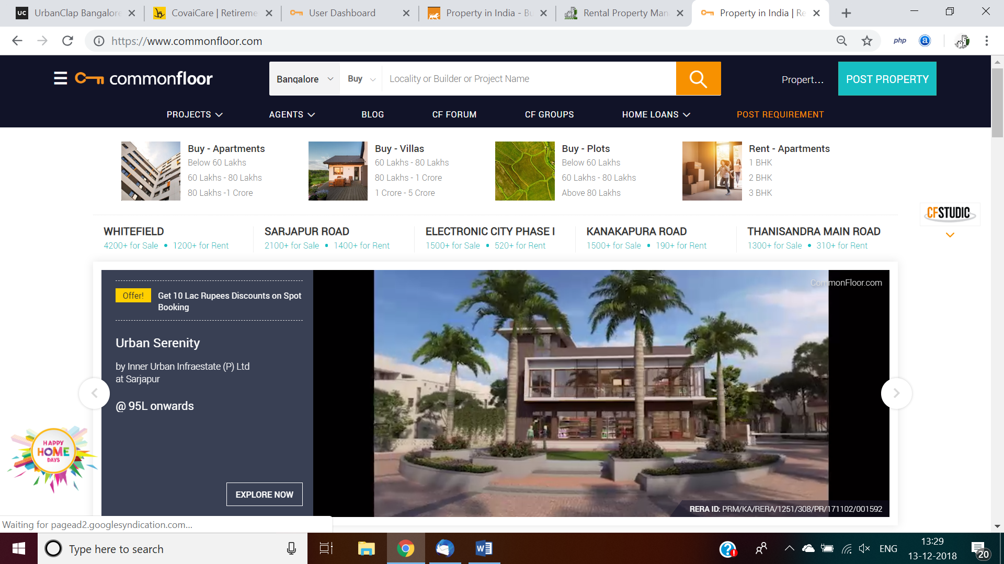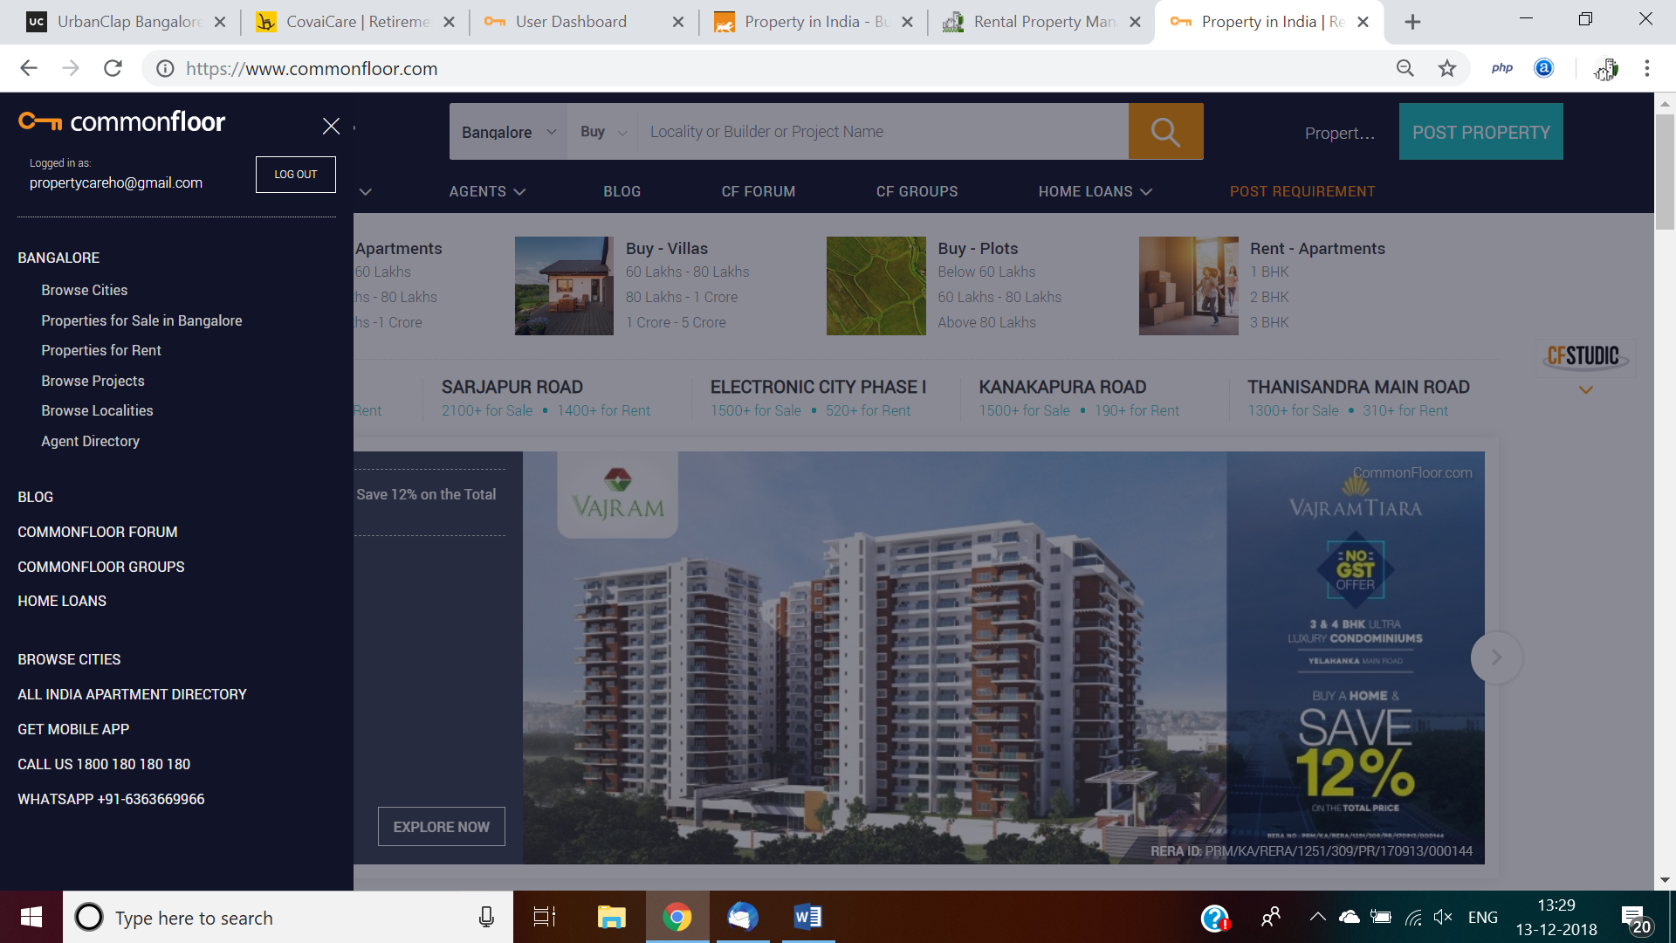mao

1. **Career page**Good decent career page to advertise roles like marketing team, accountant etc, existing version, serving purpose, <http://propertycare.co.in/career>, t_career.sql available, leverage it. Admin should receive response and reply.
2. **FAQ**Retain existing FAQs, text need to be tweaked a bit, leverage faq table, no hard code, table from table, user will keep add and delete whenever required.
3. **Contact us page**

<https://www.proptiger.com/contactus>

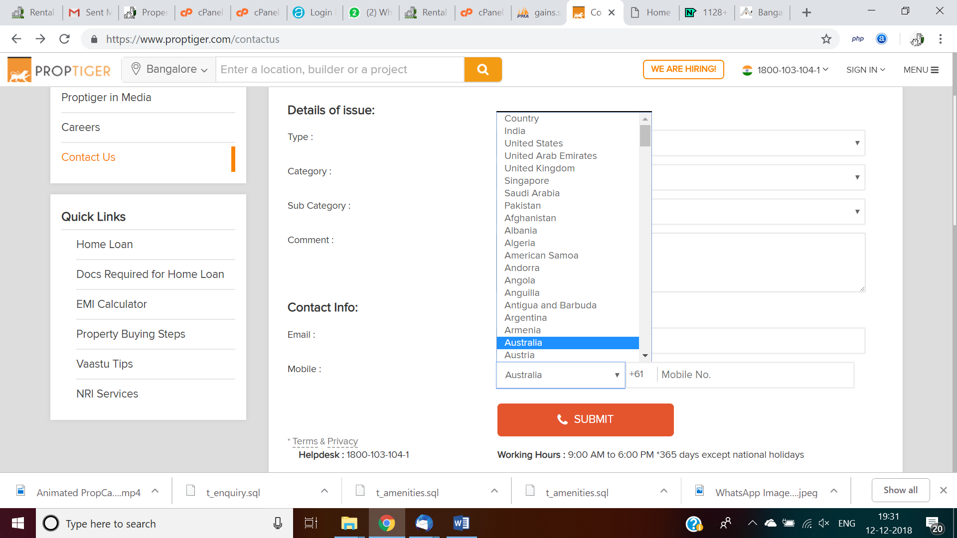

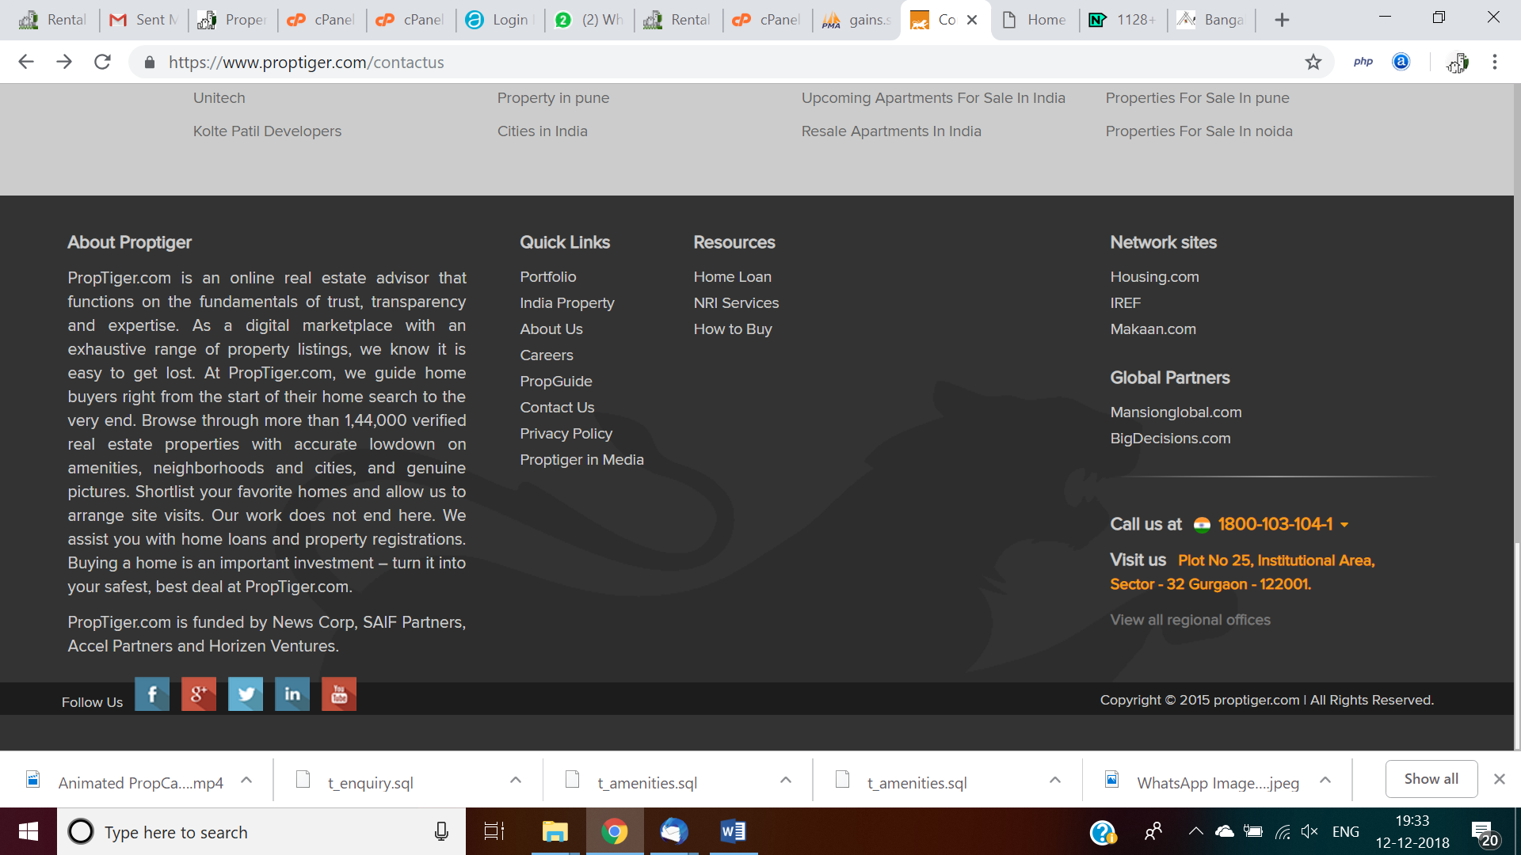

1. **Release 2, [NOT PART OF CURRENT SCOPE AND COST]**
   1. Mobile OTP by SMS/Whatsapp with option to choose, if required in release 1 itself.
   2. Lead management and lead sales to property agents, builders

Lead sale, sample thru portal:   
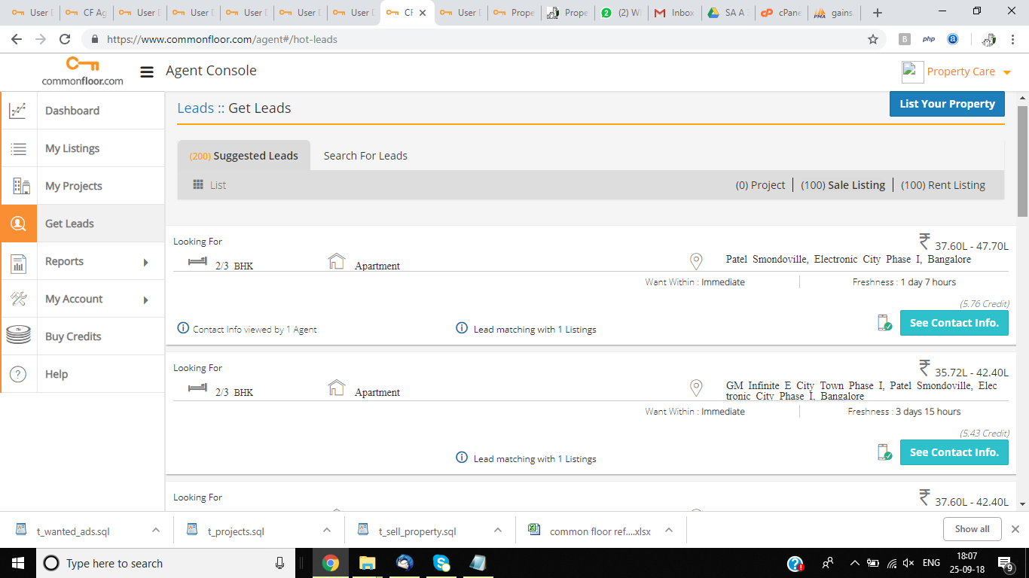

* 1. Owner and tenant agreement data collection and generate owner and tenant agreement.
  2. Collect lead with viewing appointment
  3. [www.facebook.com/propertycareho](http://www.facebook.com/propertycareho), linkedin, instagram, google reviews, blog and monitoring reqd for an hour daily.



**General:**

1. Look & feel, should be professional. Show some sample before start. Ex: Zenify.in, competitor zenify.in, proptension.com, sangau.com, ad listing cos commonfloor.com, magicbricks.com, housing.com, nestaway.com
2. User login like zenify (mobile/sms/email verification required & quality leads required, eliminate junk response, or alt suggestions wanted)
3. UI should be simple and overphone we should fill customer data
4. When cursor move over there full description to be shown of property in map view.
5. User sign up not mandatory, users can send property likes with login only. Both options should work. Sending property likes should be as user friendly as ola cab book with map.
6. Use map view wherever possible, example type location and search.
7. All filter criteria image, in map should work perfectly.
8. Rich 3D animation 2/3 video clips required for the service offering. Example available in propertycare.co.in.   
     
     
   Latest additions:
9. Owner agreement data collection UI and agreement generation
10. All users should have role based access
11. All UIs should tagged with roles, CRUD permission should be configurable, not all users allowed to see all UIs. Role dependent, when user logins in automatically view other screens as per user role, eg accountants will not have access to post new property post ad
12. All UI must have provision for CRUD after logged, after any edit other than super user, should come for another review then will come for live, eg rent amount change. Property posting only once for each property, after letout, will make status 'INACTIVE', if tenant vacate, just need to make 'ACTIVE' by clicking 'Repost' button, it wl come live. No need to retype again the same property. List/grid/map view should toggle between active and inactive properties. User may select inactive property and make active without reposting, saves time.
13. Each franchise should set their radius kilometre for their service, from their office location eg. HSR office location 10 kms, if not possible to capture in map, take km in manually when franchise creation and calculate and show, overlap in franchise is possible, eg cafe day.
14. lead responses should go to ad posted franchise and show those each lead matched properties should be shown for other available options.
15. Review has to happen by another person in same team, although franchise admin posting ad, another person have to review in his/her team, but review must; customer posted ads respective franchise business user/ admin should review. It should be configurable by franchise admin.
16. PROVISON REQUIRED: IF A FRANCHISE WANTED RUN WITH THEIR OWN BRAND, BY UPLOADING THEIR OWN LOGO, NAME IT SHOULD WORK, PROVISION TO RUN BUSINESS WITHOUT PROPERTY CARE BRAND, THEIR OWN BRAND. JUST THINK WILL DISCUSS. TECHNICALLY ALL LOGIC WILL REMAIN SAME.
17. Franchise profile, add land line 1, 2 (keep optional), ad logo, default ‘Property Care’ [in case operate in other brand], company name ‘Property Care’ default, or user typed name
18. Customer login - My leads, also a wanted customer, leverage this as requirement and show in map view as this customer has requirement in this apt, use wanted table only for lead response, also when we select this lead, another link should show matching available properties for this customer, similarly vice versa, when select property in property view, another link for matched leads, should show all matched leads.
19. Leads can shared across franchise, view contact no should have restricted access, need admin additional permission and should attached role login.
20. Provision to publish in other site from our site once tieup done with vendors like housing.com, commonfloor.com etc, from our site we can activate commonfloor ad and deactivate commonfloor ad, pl see leasing module in appfolio. Web services and API we need check with these other vendors.
21. All ads, leads should have created by, created date, updated by, and updated date, pl refer existing schema
22. One apt will have multiple properties to rent out, onclick of each property in drop down, should show respective property photos, videos and specification, refer 99acres.com for more details.
23. Tenant agreement data collection and agreement generation
24. Note the message ‘Continue with Google login’, 1st, 2nd linkedin
25. Excellent error tracking and logging mechanism, any moment property manager should see log of warnings, errors in admin console and machine to report technical team to solve in short span of time.
26. Areawise map view of selected city in search bar, default bangalore: like eteach reqd  
      
    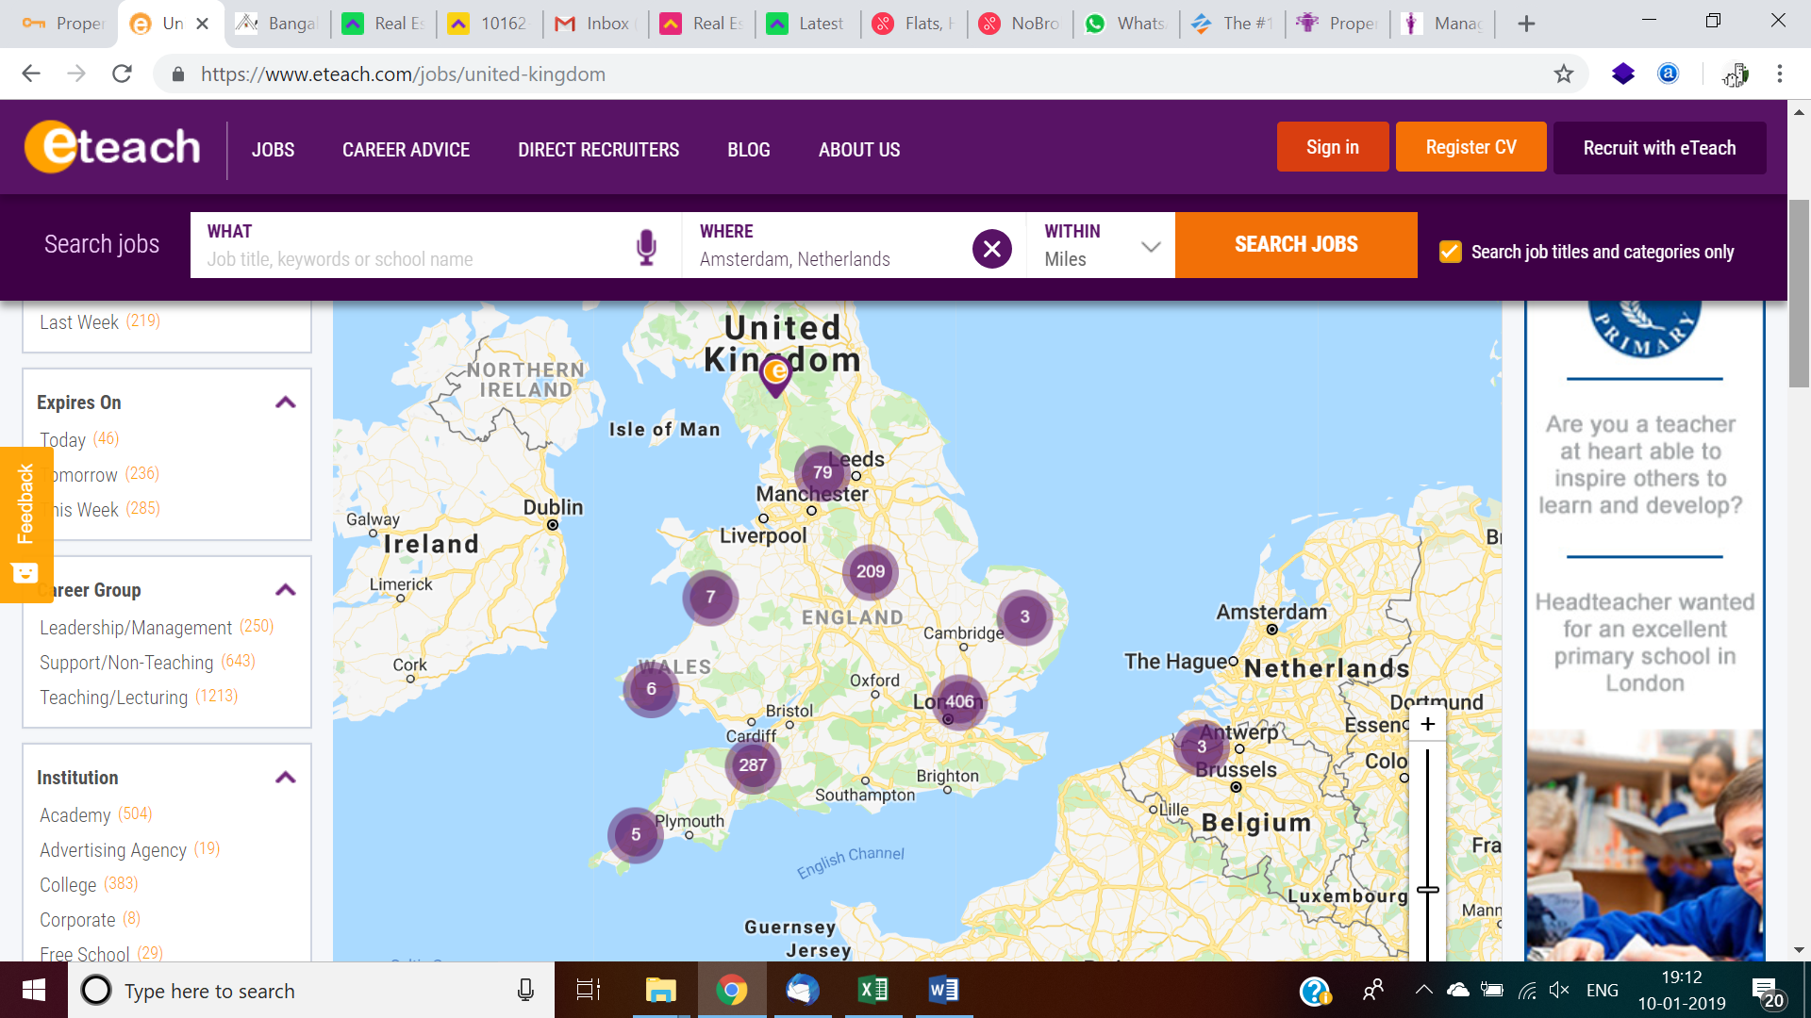

Properties grouping, zoom in, zoom out required like this to give great user experience and narrow to the area exactly required. Show all properties in entire area is not making sense.   
  
Other inputs: List view columns should be swapable, addable, deletable for ease of use for business user Photo, video slides, sample in mobile, same approach can be used for web version too